Was the use of the atomic bomb justified?

Document 1

The following is an excerpt from historian Laura Hillenbrand’s book Unbroken.
Japan held 132,000 POWs. Of those, nearly 36,000 died, more than one in every four.
Americans fared particularly bad; of the 34,648 Americans held by Japan, 12,935—more than 37 percent—died. By comparison, only 1 percent of Americans held by Nazis and Italians died. Japan murdered thousands of POWs on death marches, and worked thousands of others to death in slavery, including some 16,000 POWs who died alongside as many as 100,000 Asian laborers forced to build the Burma-Siam Railway. Thousands of other POWs were beaten, burned, stabbed, or clubbed to death, shot, beheaded, killed during medical experiments, or eaten alive in ritual acts of cannibalism. And as a result of being fed grossly inadequate and befouled food and water, thousands more died of starvation and easily preventable disease. Of the 2,500 POWs at Borneo’s Sandakan camp, only 6, all escapees, made it to September 1945 alive. Left out of the numbering statistics are untold numbers of men who were captured and killed on the spot or dragged to places like Kwajalein, to be murdered without the world ever learning their fate.
In accordance with the kill-all order, the Japanese massacred all of 5,000 Korean captives on Tinian, all of the POWs on Ballale, Wake, and Tarawa, and all but 11 POWs at Palawan. They were evidently about to murder all the other POWs and civilian internees in their custody when the atomic bomb brought their empire crashing down.

Document 2

David Kennedy. Freedom from Fear. New York: Oxford University Press, 2001. Pp. 840-841.
The “decision” to use the bomb might better be described as a series of decisions not to disturb the momentum of a process that was more than three years old by the spring of 1945 and was rapidly moving toward its all but inevitable climax. In a profound sense, the determination to use the bomb at the earliest possible date had been implicit in the original decision to build it at the fastest possible speed. “Let there be no mistake about it,” Truman later wrote. “I regarded the bomb as a military weapon and never had any doubt that it should be used.” Winston Churchill put it this way: “the decision whether or not to use the atomic bomb to compel the surrender of Japan was never even an issue. There was unanimous, automatic, unquestioned agreement around our table; nor did I ever hear the slightest suggestion that we should do otherwise.”

Document 3

Below is the translated version of the text which appeared on leaflets dropped in Japanese cities in August 1945.
ATTENTION JAPANESE PEOPLE. EVACUATE YOUR CITIES.
Because your military leaders have rejected the thirteen part surrender declaration, two momentous events have occurred in the last few days.

The Soviet Union, because of this rejection on the part of the military has notified your Ambassador Sato that it has declared war on your nation. Thus, all powerful countries of the world are now at war with you.
Also, because of your leaders' refusal to accept the surrender declaration that would enable Japan to honorably end this useless war, we have employed our atomic bomb.

A single one of our newly developed atomic bombs is actually the equivalent in explosive power to what 2000 of our giant B-29s could have carried on a single mission. Radio Tokyo has told you that with the first use of this weapon of total destruction, Hiroshima was virtually destroyed.

Before we use this bomb again and again to destroy every resource of the military by which they are prolonging this useless war, petition the emperor now to end the war. Our president has outlined for you the thirteen consequences of an honorable surrender. We urge that you accept these consequences and begin the work of building a new, better, and peace-loving Japan.

Act at once or we shall resolutely employ this bomb and all our other superior weapons to promptly and forcefully end the war.
EVACUATE YOUR CITIES.

Document 4

In December 1946, President Truman wrote a letter to Roman Bohnen, an actor who appeared in the film The Beginning or the End. The film was a documentary-like look at Truman’s decision to drop the atomic bomb on Japan in August 1945. Below are excerpts from Truman’s letter to Bohnen.
The only objection to the film, as it was, was that it appeared to have been a snap judgement program. It was anything but that- the use of the atomic bomb was deliberated for long hours and many days and weeks, and it was discussed with the Secretary of the State, the Secretary of War, the Secretary of the Navy, and the General Staff of the Allied Armies, as well as with Mr. Churchill and Mr. Attlee.
When it was finally demonstrated in New Mexico that the operation of the bomb was a successful one, it was decided to give the Japanese ample warning before the bomb was dropped. I have no qualms about it whatever for the simple reason that it was believed the dropping of not more than two of these bombs would bring the war to a close. The Japanese in their conduct of the war had been vicious and cruel savages and I came to the conclusion that if two hundred and fifty thousand young Americans could be saved from slaughter the bomb should be dropped, and it was.
A survey was made and the cities on which the bombs were dropped were those which were devoted almost exclusively to the manufacture of ammunition and weapons of destruction.

Document 5

In the evening of August 6, 1945, President Truman and the White House issued a press release concerning the dropping of the atomic bomb. Below are excerpts from that statement.
Sixteen hours ago an American airplane dropped one bomb on [Hiroshima] and destroyed its usefulness to the enemy. That bomb had more power than 20,000 tons of T.N.T. It had more than two thousand times the blast power of the British “Grand Slam,” which is the largest bomb ever yet used in the history of warfare.

The Japanese began the war from the air at Pearl Harbor. They have been repaid many fold. And the end is not yet.

Document 6

The following is an excerpt from The History Place, a secondary source website compiled by historian Philip Gavin.
In December of 1937, the Japanese Imperial Army marched into China's capital city of Nanking and proceeded to murder 300,000 out of 600,000 civilians and soldiers in the city. The six weeks of carnage would become known as the Rape of Nanking and represented the single worst atrocity during the World War II era in either the European or Pacific theaters of war.

Throughout the city of Nanking, random acts of murder occurred as soldiers frequently fired their rifles into panicked crowds of civilians, killing indiscriminately. Other soldiers killed shopkeepers, looted their stores, then set the buildings on fire after locking people of all ages inside. They took pleasure in the extraordinary suffering that ensued as the people desperately tried to escape the flames by climbing onto rooftops or leaping down onto the street.

The incredible carnage - citywide burnings, stabbings, drownings, strangulations, rapes, thefts, and massive property destruction - continued unabated for about six weeks, from mid-December 1937 through the beginning of February 1938. Young or old, male or female, anyone could be shot on a whim by any Japanese soldier for any reason. Corpses could be seen everywhere throughout the city. The streets of Nanking were said to literally have run red with blood.
Those who were not killed on the spot were taken to the outskirts of the city and forced to dig their own graves, large rectangular pits that would be filled with decapitated corpses resulting from killing contests the Japanese held among themselves. Other times, the Japanese forced the Chinese to bury each other alive in the dirt.

Was the use of the atomic bomb justified?

Document 7
Gar Alperovitz, Review of David McCullough's Truman, The Nation, May 10, 1993
Historians continue to debate why Truman dropped the bomb. But archival documents leave no doubt that Truman knew that the war would end “a year sooner now” and without an invasion. One of the main reasons was his awareness that the shock of an early Soviet declaration of war was expected to jolt Japan into surrender long before an invasion could begin. [Other historians] have effectively refuted Truman's oft repeated argument about the number of American lives saved by the bomb. [Stanford University's Barton] Bernstein could not find a worst case prediction of lives lost higher than 46,000—even if an invasion had been mounted. “The myth of the 500,000 American lives saved” Bernstein concludes, “thus seems to have no basis in fact.” ...At least one of the factors in the minds of those making the decision to use the atomic bomb involved geo-political and diplomatic concerns about the Soviet Union.

Document 8

On July 17, 1945, a group of scientists working on the Manhattan Project wrote a petition to President Truman asking him not to use the atomic bomb. Below are excerpts from that petition.
Discoveries of which the people of the United States are not aware may affect the welfare of this nation in the near future… [A]s Commander-in-Chief, the fateful decision whether or not to sanction the use of such bombs in the present phase of the war against Japan [is in your hands].
The war has to be brought speedily to a successful conclusion and attacks by atomic bombs may very well be an effective method of warfare. We feel, however, that such attacks on Japan could not be justified, at least not unless the terms which will be imposed after the war on Japan were made public in detail and Japan were given an opportunity to surrender.
…Thus a nation which sets the precedent of using these newly liberated forces of nature for purposes of destruction may have to bear the responsibility of opening the door to an era of devastation on an unimaginable scale.

Document 9

Below are a series of pictures from Hiroshima and Nagasaki in the aftermath of the bomb.

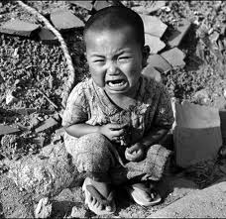
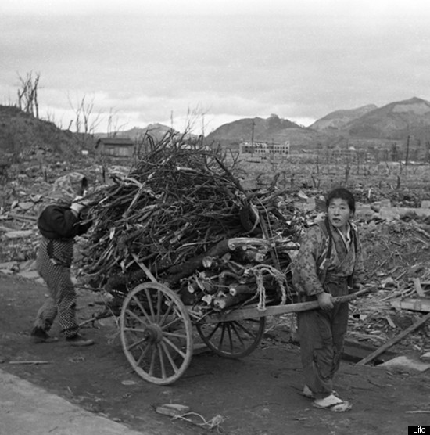

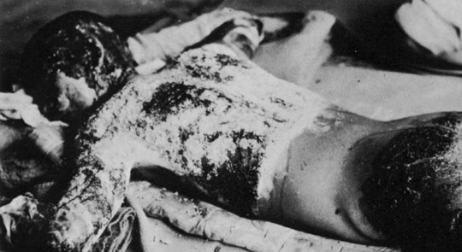

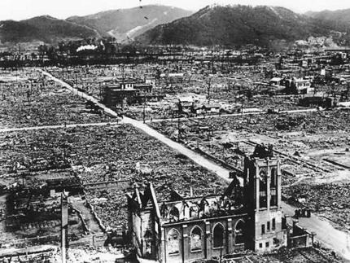

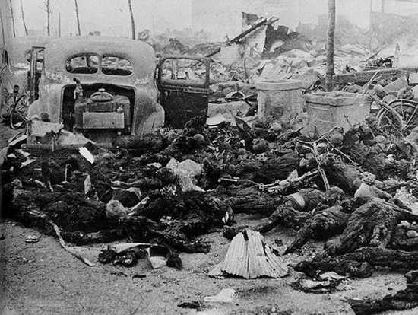

Document 10

The following excerpts are from the novel Hiroshima which tells the stories of six survivors of the bombing of Hiroshima.
Timbers fell around her as she landed, and a shower of tiles pommelled her; everything became dark, for she was buried. The debris did not cover her deeply. She rose up and freed herself. She heard a child cry, “Mother, help me!,” and saw her youngest—Myeko, the five-year-old—buried up to her breast and unable to move. As Mrs. Nakamura started frantically to claw her way toward the baby, she could see or hear nothing of her other children.

Dr. Sasaki shouted the name of the chief surgeon and rushed around to the man’s office and found him terribly cut by glass. The hospital was in horrible confusion: heavy partitions and ceilings had fallen on patients, beds had overturned, windows had blown in and cut people, blood was spattered on the walls and floors, instruments were everywhere, many of the patients were running about screaming, many more lay dead. (A colleague working in the laboratory to which Dr. Sasaki had been walking was dead; Dr. Sasaki’s patient, whom he had just left and who a few moments before had been dreadfully afraid of syphilis, was also dead.) Dr. Sasaki found himself the only doctor in the hospital who was unhurt.

Mr. Tanimoto, fearful for his family and church, at first ran toward them by the shortest route, along Koi Highway. He was the only person making his way into the city; he met hundreds and hundreds who were fleeing, and everyone of them seemed to be hurt in some way. The eyebrows of some were burned off and skin hung from their faces and hands. Others, because of pain, held their arms up as if carrying something in both hands. Some were vomiting as they walked. Many were naked or in shreds of clothing. On some undressed bodies, the burns had made patterns—of undershirt straps and suspenders and, on the skin of some women (since white repelled the heat from the bomb and dark clothes absorbed it and conducted it to the skin), the shapes of flowers they had had on their kimonos. Many, although injured themselves, supported relatives who were worse off. Almost all had their heads bowed, looked straight ahead, were silent, and showed no expression whatever.

Document 11

From Commonwealth's editorial of August 24, 1945:
There was a port in the Pacific which sheltered American naval power. It was attacked by air without warning and the name Pearl Harbor was associated, and seemed likely to be associated for many years, with a Japanese idea that you could win a war by attacking the enemy before declaring war on the enemy. The name Pearl Harbor was a name for Japanese guilt and shame. The name Hiroshima, the name Nagasaki are names for American guilt and shame.

The war against Japan was nearly won. Our fleet and Britain’s fleet stood off Japan’s coast and shelled Japan’s cities. There was no opposition. Our planes, the greatest bombers in the world flew from hard won, gallantly won bases and bombed Japanese shipping, Japanese industry and, already, Japanese women and children. Each day they announced to the Japanese where the blows would fall, and the Japanese were unable to prevent anything they chose to do. Then, without warning an American plane dropped the atomic bomb on Hiroshima.

Russia entered the war. There was no doubt before or after Russia entered the war that the war against Japan was won. An American plane dropped the second atomic bomb on Nagasaki.

…For our war, for our purposes, to save American lives we have reached the point where we say that anything goes. That is what the Germans said at the beginning of the war. Once we have won our war we say that there must be international law. Undoubtedly. When it is created, Germans, Japanese, and Americans will remember with horror the days of their shame.

Document 12

American History Textbook, American Vision, pg. 615.

Document 13
Even before the bomb was tested, American officials began to debate how to use it. Admiral William Leahy, Chairman of the Joint Chiefs of Staff, opposed using the bomb because it killed civilians indiscriminately. He believed that an economic blockade and conventional bombing would convince Japan to surrender.

Secretary of War Henry Stimson wanted to warn the Japanese about the bomb while at the same time telling them that they could keep the emperor if they surrendered. Secretary of State James Byrnes, however, wanted to drop the bomb without any warning to shock Japan into surrendering.

President Truman later wrote that he “regarded the bomb as a military weapon and never had any doubts that it should be used.” His advisers had warned him to expect massive casualties if the United States invaded Japan. Truman believed it was his duty as president to use every weapon available to save American lives.

Paul Fussell, a World War II Soldier, Thank God for the Atom Bomb,1990.

My division, like most of the ones transferred from Europe was going to take part in the invasion at Honshu (an island of Japan). The people who preferred invasion to A-bombing seemed to have no intention of proceeding to the Japanese front themselves. I have already noted what a few more days would mean to the luckless troops and sailors on the spot…. On Okinawa, only a few weeks before Hiroshima, 123,000 Japanese and Americans killed each other. War is immoral. War is cruel.

Document 14
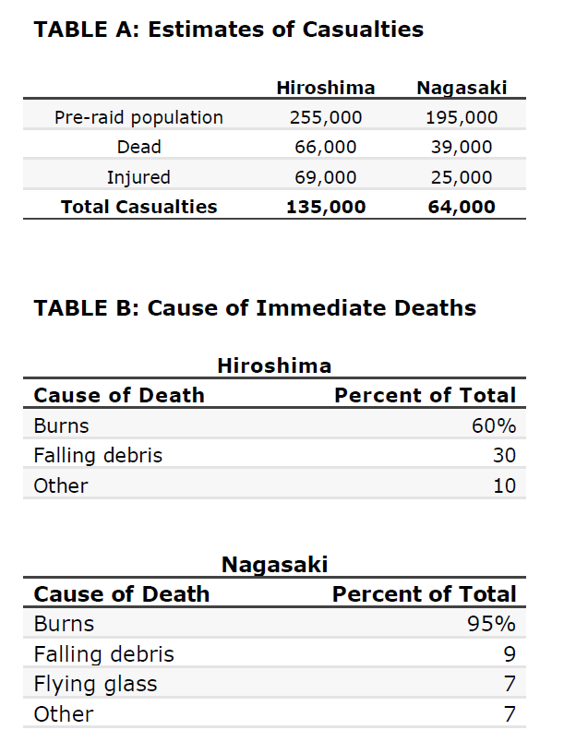

Document 15
Source: Ribowsky, Shiya. “Coroner’s Report,” History Channel. Video.

Go to the class website. Under Semester 1, Foreign Policy, World War II, you will find the video under today’s date.

