Aware that support for protests in Birmingham was waning during April 1963, Dr. Martin Luther King, Jr. and the SCLC looked for ways to jumpstart the campaign. When the arrest and jailing of King did little to attract more protestors, SCLC staff member James Bevel proposed recruiting local students, arguing that while many adults may be reluctant to participate in demonstrations for fear of losing their jobs, their children had less to lose. King initially had reservations, but after deliberation he agreed, hoping for the action to “subpoena the conscience of the nation to the judgment seat of morality.” SCLC and the Alabama Christian Movement for Human Rights (ACMHR) members immediately canvassed colleges and high schools for volunteers and began training them on the tactics of nonviolent direct action.
A passion for freedom sweeps through Parker High and the other Black schools of Birmingham and Bessemer, an emotional firestorm ignited by SCLC's young field workers. It's led by class presidents and prom queens, cheerleaders and football heroes like big James Orange. It's a fire stoked and spread by "Tall Paul" White and other DJs at the Black radio stations. Thursday, May 2nd, is "D-Day" as students "ditch" class to march for justice. In disciplined groups of 50, children singing freedom songs march out of 16th Street Baptist church two-by- two. When each group is arrested, another takes its place. There are not enough cops to contain them, and police reinforcements are hurriedly summoned. By the end of the day almost 1,000 kids have been jailed.
That evening, almost 2,000 adults over-flow the nightly mass meeting at Bethel Baptist. As mandated by a court ruling, a pair of white police detectives are able to attend all mass meetings so that they can radio reports back to Connor. They usually sit in the front row and Movement speakers often address them directly as representatives of the repressive power-structure. By confronting them, condemning their actions, and ridiculing them with humor, the speakers use their presence to erode the deeply ingrained traditions of fear and subservience that have held sway for so long.
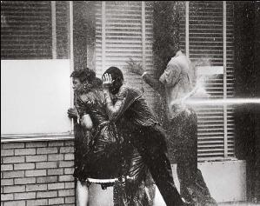
The next day, Friday May 3rd, a thousand more students cut class to assemble at 16th Street church. With the jails already filled to capacity, and the number of marchers growing, Connor decides to suppress the movement with violence. Instead of arresting the first group of marchers he orders his fire department to disperse them with firehoses. But the students hold their ground, singing "Freedom" to the ancient hymn "Amen." Connor orders the water pressure increased to knock them off their feet and wash them away. Still singing, the young protesters sit down on the pavement and hunch their backs against the torrent.
Connor brings up "monitor guns," high-pressure nozzles mounted on tripods and fed by two hoses that are used to fight the worst fires. They're capable of knocking bricks out of a wall at 100 feet. The students are washed tumbling down the street like leaves in a flood. Outraged, the hundreds of Black on-lookers in Kelly Ingram park — including many parents — throw rocks and bottles at the cops and firemen. Meanwhile, more groups of marchers are taking different routes out of 16th Street church, dodging around the firehoses and heading for downtown. The cops scramble to block them, arresting those who reach City Hall or the downtown stores. There is no room in the jails and the overflow prisoners are incarcerated at the county fairgrounds.
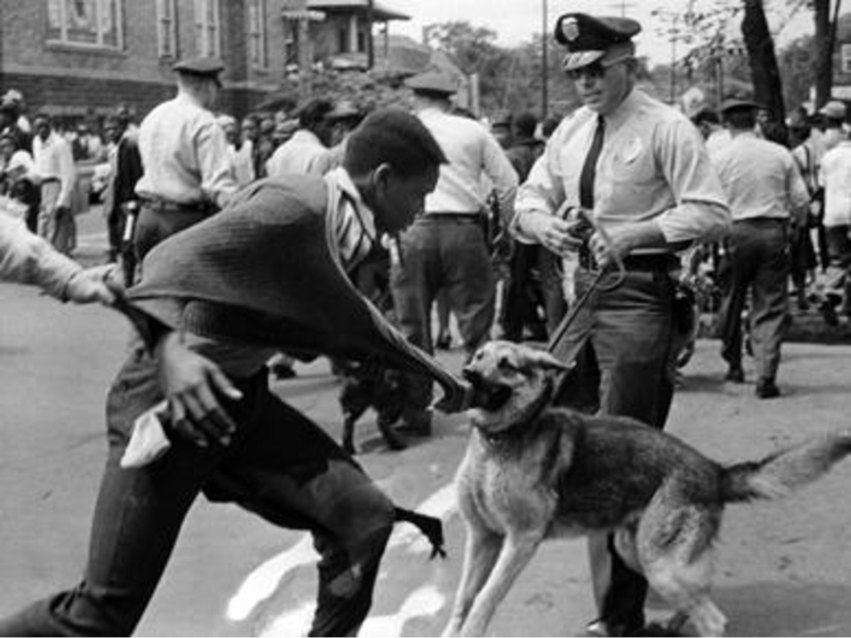
To contain and intimidate the demonstrators and the angry crowd, Connor brings up his K9 Corps of eight vicious attack dogs. As John Lewis recalled it later, "We didn't fully comprehend at first what was happening. We were witnessing police violence and brutality Birmingham-style: unfortunately for Bull Connor, so was the rest of the world." Television that night, and newspapers world-wide the next morning, show images of young children marching up to snarling police dogs, cops clubbing women to the ground, and high-pressure hoses sweeping young bodies into the street.
Saturday, May 4th, the student marches continue. Again Connor uses his monitor water-cannons to knock down and contain the young protesters, and again they use guerrilla tactics to evade the police cordon to reach City Hall and the downtown shopping district. Connor knows he cannot use fire hoses or attack dogs against Blacks intermingled with white shoppers, so he has to arrest those who reach the commercial area, straining the capacity of his improvised prisons at the fair grounds. Again angry adults in Kelly Ingram park retaliate by hurling rocks and bottles at the cops and firemen until Bevel and other SCLC workers convince them that their spontaneous violence is undercutting the Movement's effectiveness.
With the downtown stores closed for Sunday, the 5th is to be a day of pause, prayer, and nonviolent training for the next wave. Reinforcements arrive — SNCC Executive Director James Forman just bailed out from being arrested on the William Moore march, SNCC leader Ella Baker, comedian Dick Gregory, and singers Guy & Candy Carawan and Joan Baez. But when the cops bust the Carawans, dragging them off the steps of New Pilgrim church (site of that day's mass meeting), Bevel calls on the congregation — mostly adults in their Sunday best — to march on the jail in protest.
Stung by growing public pressure, and moved by the images coming out of Birmingham, Kennedy sends Justice Department official Burke Marshall to calm the waters. Marshall tries without success to convince King that the demonstrations should be halted. And he finds few whites of influence willing to sit down and negotiate with Blacks.
On Monday, the 6th, under pressure from a white power-structure desperate to avoid new images of savage brutality, Connor agrees to simply arrest anyone who tries to march rather than trying to beat them into submission with clubs, dogs, and firehoses. Led by Dick Gregory, the first group is arrested as they leave 16th Street church, and hour after hour, group after group are taken off to jail — almost 1,000 by day's end (more than 2,600 since D-Day). The jails are full, the improvised fairground prison is full, and many prisoners are now held in an open-air stockade without shelter from the rain. But the downtown shopping district is deserted, the stores empty as Blacks continue to boycott and white shoppers avoid the turmoil of demonstrators and massive police operations. And at the huge mass meeting that night, spread across four different churches, more children — and an increasing number of adults — step forward to march the next day.
On Tuesday the 7th, the Movement escalates its boycott tactics. While Walker and Bevel hold Connor's attention by making themselves visible at 16th Street church apparently organizing more marches, 600 students led by Dorothy Cotton, Isaac Reynolds, Jim Forman, and others sneak downtown in small guerrilla groups. At H-Hour they grab signs hidden in parked cars and set up surprise picket lines all over the main shopping district. As the cops race towards downtown from Kelly Ingram park with sirens wailing, hundreds of young protesters dash out of the church, evade the few remaining cops, and stream downtown to join the others.
Lines of students, now joined by hundreds of adults, weave in and out of stores, dancing to the rhythmic beat of freedom songs. Within the hour, thousands of protesters are picketing, sitting-in, blocking streets, and taunting the cops. The entire central district is gripped by nonviolent pandemonium. The News reports the next day: Sirens Wail, Horns Blow, Negroes Sing. The cops are stumped, the jails and holding pens are full and the budget exhausted, they cannot make more mass arrests, but they cannot shoot up Birmingham's business heart with tear gas, or risk damaging stores and offices with high-pressure fire hoses aimed at quickly dodging demonstrators.
Back at Kelly Ingram park, the fire hoses are turned on new waves of nonviolent marchers coming out of the church. A high-pressure blast from a monitor gun is aimed at Shuttlesworth, smashing him against the brick wall of the church until he collapses. As he is rushed to hospital by ambulance, Bull Connor tells a reporter: "I wish he'd been carried away in a hearse."

