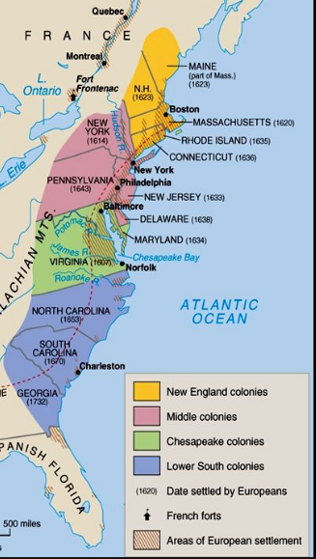

Maryland

Virginia

Pennsylvania

Rhode Island

Massachusetts