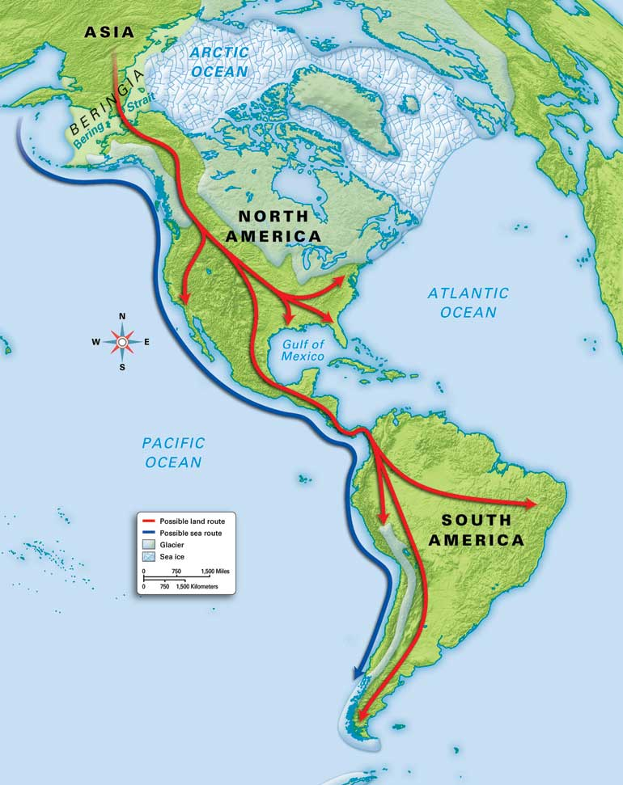
The Columbian Exchange
Over 13,000 years ago, the Ice Age forced hunter-gatherers to travel across a land bridge from Asia to North America in search of food. At the end of the Ice Age, the glaciers melted flooding this bridge and separating the world. For the next 12,000 years, the world remained divided with minimal interaction between the two worlds: on one half, “the Old World,” which consisted of the continents of Africa, Asia, and Europe; on the other, “the New World,” which consisted of North and South America. These two worlds had distinctly different places and animals which would shape the way their civilizations emerged.

Directions: Based on your own base knowledge, make an informed guess about the origins of each resource below. Write an “O” if you think that it originated in the Old World and a “N” if you think that it originated in the New World.

Apples:____________

Bananas: __________

Chocolate: _________

Turkeys: __________

Cattle: _____________

Potatoes: _________

Coffee: ____________

Broccoli: __________

Corn: ______________

Tobacco: ___________

Chickens: ___________

Horses: _____________

Pineapples: _________

Tomatoes: __________

Malaria: ____________

Tea: ________________

Smallpox: _________

Llamas:___________

Measles: ___________

Mumps: ___________

In the year 1492, Christopher Columbus sails the Ocean blue. He crosses the Atlantic Ocean and lands in the Caribbean. Columbus was not the first to accomplish this feat; however, following his accomplishment, other Europeans would soon follow. This would end thousands of years of isolation between the two worlds. What would follow is a period of exchanging goods that the other half previously never knew existed. This exchange of goods is known as the Columbian Exchange.

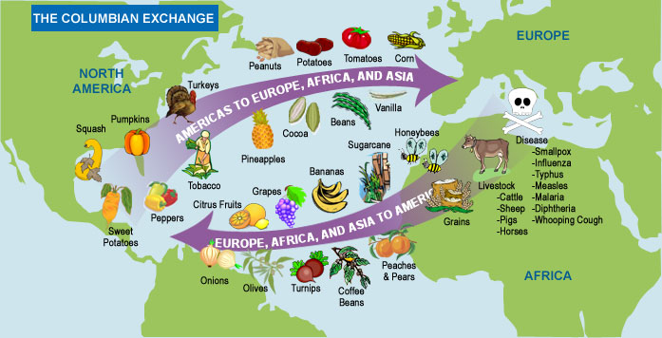
Directions: Select one item from the list on the front. Explain the impact you anticipate it will have on the other culture. In other words, what might be the effects of this product on the other civilization?

