

**Contact Information**

**Where in the world is Mr. Gaughan?**

**Email*:*** [pgaughan@d120.org](mailto:pgaughan@d120.org)

**1st:** C204

**2nd:** C204

**3rd:** C204

**4th:** Study Cafe

**5th:** C204

**6th:** Lunch

**7th:** C204

**8th:** Prep

**Unsure?** C204 or Foreign Language Office

**Availability for Mr. G:**

3:05-3:35pm or 7:00-7:30am

The purpose of the Advanced Placement course in United States History is to provide you with the factual knowledge and analytical skills necessary to deal critically with issues and problems found throughout American history. The course of study in this class is reflective of the experience you would obtain in most college introductory American history classes.

This course is designed to prepare you to succeed on the AP Exam which is given in early May, as well as prepare you for intermediate college courses in American history. You will learn to assess historical materials for their reliability, relevance, and importance and use this evidence to develop reasoned judgments. These reasoned judgments will be used in class discussions and often are the basis of written essays. Each unit will conclude with an exam consisting of multiple-choice questions as well as essay questions. The essays may be Document Based Questions and/or Free Response Essays.

While there is little to be gained from rote memorization of names and dates, you must be able to draw on factual knowledge in order to exercise analytical skills intelligently. It is expected that you will come to class each day with that factual knowledge so that you will be a contributing member of the class.

The outline you will receive for this course was prepared by the College Board to illustrate the topics that may appear on the AP Exam. These topics will encompass the basis of the course. There shall be review sessions prior to the AP Exam in May.

AP United States

**Course Description**

*History*

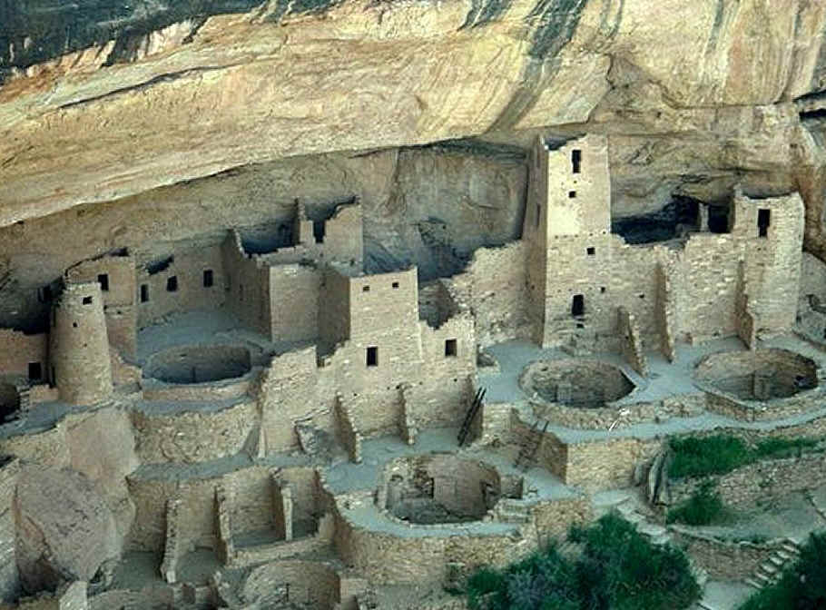

**Unit 1: 1491-1607**

* **Pre-Columbian Natives, Columbian Exchange, New Spain, Black Legend, Encomienda, New France**

**Course Content**



**Unit 2: 1607-1754**

* **Jamestown, Plymouth, British colonies**

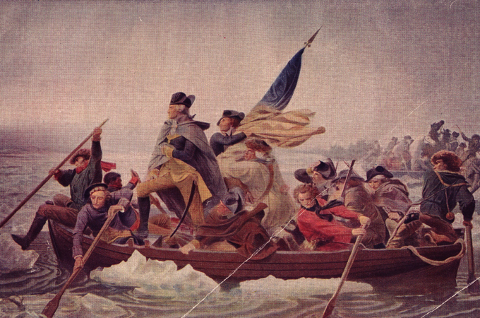

**Unit 3: 1754-1800**

* **American Revolution, Boston Tea Party, Declaration of Independence, Constitutional Convention**



**Unit 4: 1800-1848**

* **Louisiana Purchase, War of 1812, Market Revolution, Trail of Tears, Seneca Falls Convention**



**Unit 5: 1844-1877**

* **Mexican-American War, Republican Party, Civil War, Emancipation Proclamation, Reconstruction**



**Unit 6: 1865-1898**

* **Manifest Destiny, Industrial Revolution, Gilded Age**



**Unit 7: 1890-1945**

* **American Imperialism, Progressivism, WWI, Roaring 20s, Great Depression, WWII**



**Unit 8: 1945-1980**

* **Korean War, Civil Rights, Great Society, Vietnam War**



**Unit 9: 1980-Present**

* **Reagan, September 11th, War on Terror**

C:\STOCKLAYOUTS\CURRENT PROJECTS\FN99803-PL\FN99803-IMG11.emf

**Course Materials:**

Grading Policy

All grades in this class will be measured against established content and skills standards for this course.

Summative assessments are the final assessments that measure what a student has learned over the course of a unit or term. 70 % of grades in this class will be based

on summative assessments, which include tests, quizzes, papers, and projects.

The other 30% will be based on exercises designed to prepare you for these assessments such as: in-class activities and homework.



C:\STOCKLAYOUTS\CURRENT PROJECTS\FN99803-PL\FN99803-IMG10.emf

1. **Textbook: Give Me Liberty**
2. **Notebook or loose leaf paper kept in binder**
3. **Highlighter**
4. **Chromebook**
5. **Headphones**
6. **AP US History Review Book**

**(Highly recommended)**

**Cost ~$18.**

1. **Kleenex**

**Classwork**

**10%**

**Homework**

**20%**

**Tests**

**70%**

**Tests** will consist of either:

* 20/25 Multiple Choice
* 1 Short Answer
* Either 1 Long Essay

OR

* 1 DBQ Essay

**Homework**

**15%**

**Classwork**

**15%**

A grade is designed to represent a clear and accurate picture of what a student knows and is able to do. Grades help me to track the progress of students and reflect on my teaching, provide feedback to students and parents, and make instructional decisions regarding the students.

**Missing an Assignment?**

**Absent?**

**All of the activities for each day are posted on the class website.**

[www.apushgaughan.weebly.com](http://www.apushgaughan.weebly.com)

# http://www.google.ie/intl/en/chrome/assets/common/images/devices/samsung-chromebook/homepage-promo.jpg

# Reassessment

Students will be provided with an **opportunity** to **reassess** if they are unhappy with their performance on the summative assessment and meet the stated requirements for reassessing. Please note, that reassessments are **not a guarantee**, and I reserve the right to deny a reassessment to any student if they do not meet the stated criteria. If a student has frequent absences or tardies, does not use class time constructively, or does not complete work they will not be granted a reassessment. The grade on the reassessment will **replace** the original score only if the student’s performance improved with the reassessment.

The following steps must be taken in order for a student to earn an opportunity to reassess.

1. Have proof of **completion** of **all** **assignments** and **homework** to prove you have attempted to master the content prior to the assessment.
2. Schedule a time to meet with me to discuss your performance. This can be done before school, during lunch, or after school as needed.
3. During the meeting we will establish an *Action Plan* and *Timeline* to prepare for the reassessment.
4. Students must show evidence of completion for the *Action Plan.*

Once all steps are complete the student may complete the reassessment. This must be done before the next unit assessment.

# Technology Policy

**Acceptable Uses**: The school’s computer technology is meant to further learning and provide additional educational opportunities for the students. To protect against the possibility of misuse, computers in this classroom should be limited to teacher-defined educational purposes unless direct permission to use the computers is obtained from the teacher.

**Unacceptable Uses:** The following uses of the classroom technology are not acceptable and will result in disciplinary action.

* Using the computer without supervision or permission from a teacher
* Sending threatening messages, e-mails, or any use of the computer to intimidate others
* Downloading, uploading, or distributing any files, software, or other material of any sort unless directly authorized by the teacher
* Infringing on any copyright laws by downloading or sharing files in an inappropriate manner
* Infringing on any copyright laws by using protected materials found on the computer in an individual’s own work without proper citation (plagiarism)
* Using another’s information (i.e. email addresses, passwords) on a computer without the permission of the individual and the teacher

**TEACHER EXPECTATIONS**

All assignments are due at class-time on the date established. I **do accept late work**; however, the assignment will be reduced one letter grade for every day it is late. Unexcused absences will result in no credit given for work missed. If you are present when a test, quiz, or an assignment is announced, you are expected to take that test, quiz, or turn in that assignment immediately upon your return from an excused absence.

In an Advanced Placement class, it is important that you attend class regularly. Attendance policies will follow those found in the pathfinder. If you are excusably absent, you will receive makeup privileges. If you are truant, no credit will be given for work missed. Tardies will follow the school policy.

Students are strongly encouraged to take the AP Exam. Sign-up will be in the fall. It is your responsibility to sign-up for the AP Exam by the deadline. Review sessions will start in April. Reminders and other announcements will take place through Remind and the class website.

**AP EXAM OVERVIEW**

**Exam Date: Friday, May 8th, AM Session**

The AP Exam will be given in May. The test is 3 hours and 15 minutes long. The examination consists of a 55-minute multiple-choice (M-C) section, a 40 minute short answer (S-A) section, and a 100 minute writing section. The writing section will consist of a 60 minute Document-Based Question (DBQ) and 40 minute Long Essay Question (chosen from a pair).

The 55 question multiple choice portion of the exam will account for 40% of the exam grade and the 3 question short answer section will account for 20% of the exam grade. Within the writing section the DBQ accounts for 25% while the long essay counts for 15% of the exam grade.

The table below summarizes this information. (Source: The College Board)

**Time Number of Questions Type of Question Percent of Grade**

55 min. 55 Multiple Choice 40%

40 min. 3 Short Answer 20%

60 min. 1 DBQ 25%

40 min. 1 Long Essay 15%



Mundelein High School

1350 West Hawley St.

Mundelein, IL 60060

Text Message Updates

One option to keep both students and parents informed on upcoming assignments is the chance to receive text messages regarding upcoming assignments, projects, and tests. We use a program called Remind which prevents us from having access to students’ cell phone numbers as well as them from having our cell phone numbers. These group texts are designed to do actually that, remind students about homework assignments and test dates. Below are the directions to enroll if you are interested.

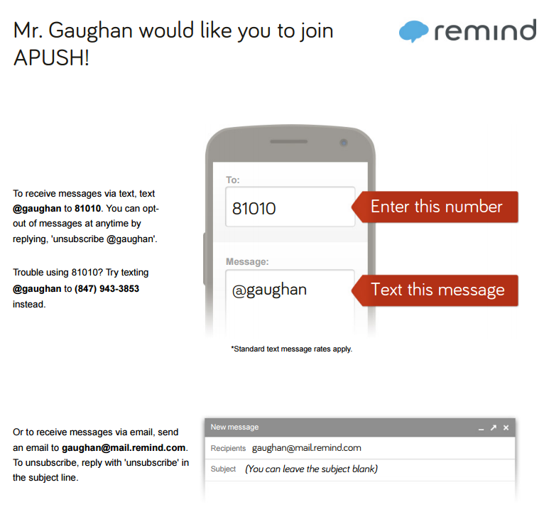

**Parent Newsletter Email**

In an effort to improve communication between teachers and parents, I offer parents the option of enrolling in a weekly email update list. Parents will receive an email periodically about in-class activities, homework, and upcoming tests and projects. This will enable you to get in touch with me and ask any necessary questions. I **highly recommend** that parents elect to enroll in the weekly email list.

Pleased sign below as to whether you are interested or not. If so, please print your email **legibly.**

_______I am interested in the email notification list.

My email address is:_____________________________________________________________________

_______I am not interested.

# Syllabus Agreement

**Please sign and return this portion of the syllabus by Monday, August 19th**

I have read and understand the expectations and requirements for U.S. History.

______________________________________ _______________________________________________

(Student name, printed) (Student signature)

I have read and understand the expectations and requirements of my child in their U.S. History class.

______________________________________ _______________________________________________

(Parent/Guardian name, printed) (Parent/Guardian signature)