UNITED STATES HISTORY
SECTION II
Total Time-60 minutes

Questions 1 (Document Based Question)
Suggested reading period: 15 minutes
Suggested writing period: 45 minutes

Directions: The following question requires you to construct a coherent essay that integrates your interpretation of Documents A-I and your knowledge of the period referred to in the question. High scores will be earned only by essays that both cite key pieces of evidence from the documents and draw on outside knowledge of the period.

Write your responses on the lined pages that follow the question.

In your response you should do the following.
- State a relevant thesis that directly addresses all parts of the question.
- Support the thesis or a relevant argument with evidence from all, or all but one, of the documents.
- Incorporate analysis of all, or all but one, of the documents into your argument.
- Focus your analysis of each documents on at least one of the following: intended audience, purpose, historical context, and/or point of view.
- Support your argument with analysis of historical examples outside the documents
- Connect historical phenomena relevant to your arguments to broader events of processes.
- Synthesize the elements above into a persuasive essay.

1. Historians have traditionally labeled the period after the War of 1812 the “Era of Good Feelings” due to shared desire for national unity and the decline of partisan disputes. Support, modify, or refute this contention using specific evidence.

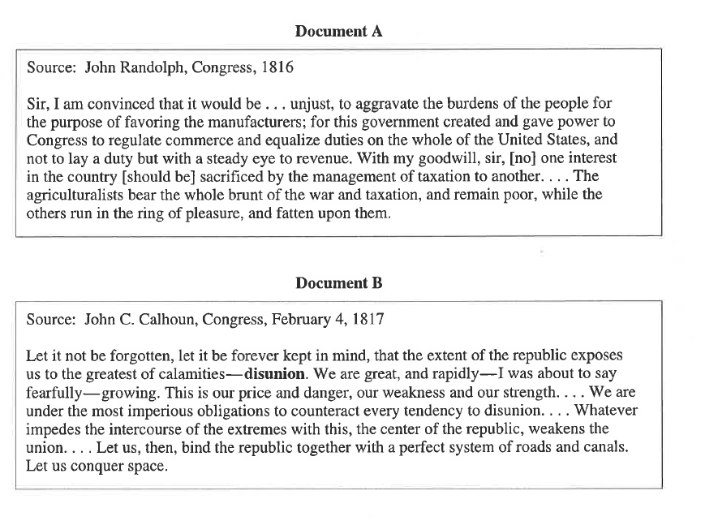

UNITED STATES HISTORY
SECTION II
Total Time-60 minutes

Questions 1 (Document Based Question)
Suggested reading period: 15 minutes
Suggested writing period: 45 minutes

Directions: The following question requires you to construct a coherent essay that integrates your interpretation of Documents A-I and your knowledge of the period referred to in the question. High scores will be earned only by essays that both cite key pieces of evidence from the documents and draw on outside knowledge of the period.

Write your responses on the lined pages that follow the question.

In your response you should do the following.
- State a relevant thesis that directly addresses all parts of the question.
- Support the thesis or a relevant argument with evidence from all, or all but one, of the documents.
- Incorporate analysis of all, or all but one, of the documents into your argument.
- Focus your analysis of each documents on at least one of the following: intended audience, purpose, historical context, and/or point of view.
- Support your argument with analysis of historical examples outside the documents
- Connect historical phenomena relevant to your arguments to broader events of processes.
- Synthesize the elements above into a persuasive essay.

1. Historians have traditionally labeled the period after the War of 1812 the “Era of Good Feelings” due to shared desire for national unity and the decline of partisan disputes. Support, modify, or refute this contention using specific evidence.

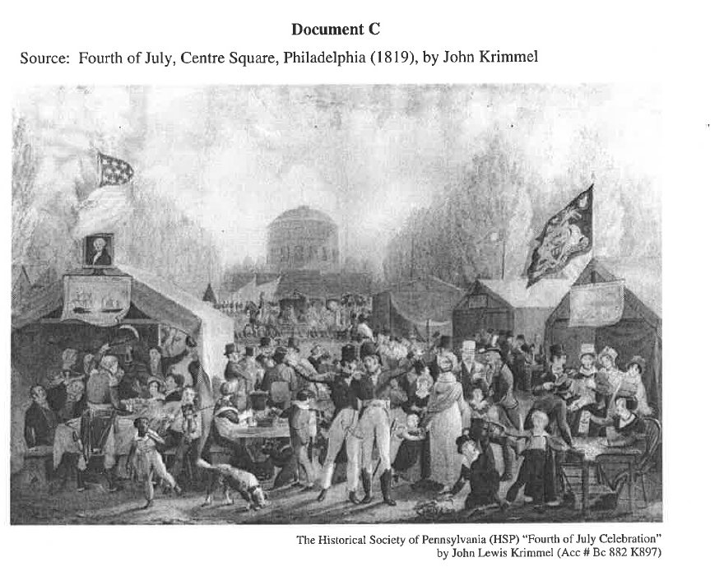
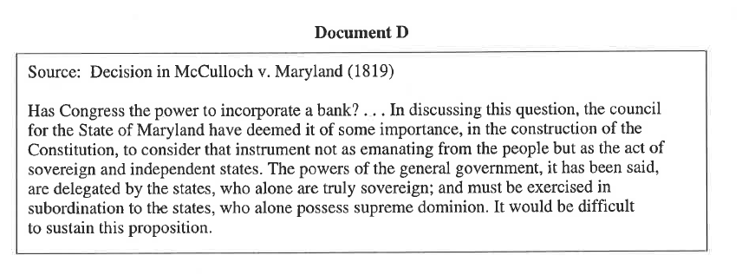

UNITED STATES HISTORY
SECTION II
Total Time-60 minutes

Questions 1 (Document Based Question)
Suggested reading period: 15 minutes
Suggested writing period: 45 minutes

Directions: The following question requires you to construct a coherent essay that integrates your interpretation of Documents A-I and your knowledge of the period referred to in the question. High scores will be earned only by essays that both cite key pieces of evidence from the documents and draw on outside knowledge of the period.

Write your responses on the lined pages that follow the question.

In your response you should do the following.
- State a relevant thesis that directly addresses all parts of the question.
- Support the thesis or a relevant argument with evidence from all, or all but one, of the documents.
- Incorporate analysis of all, or all but one, of the documents into your argument.
- Focus your analysis of each documents on at least one of the following: intended audience, purpose, historical context, and/or point of view.
- Support your argument with analysis of historical examples outside the documents
- Connect historical phenomena relevant to your arguments to broader events of processes.
- Synthesize the elements above into a persuasive essay.

1. Historians have traditionally labeled the period after the War of 1812 the “Era of Good Feelings” due to shared desire for national unity and the decline of partisan disputes. Support, modify, or refute this contention using specific evidence.

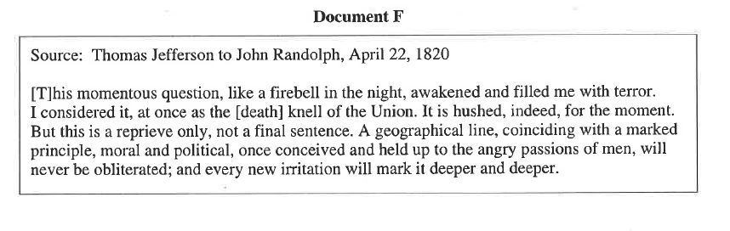
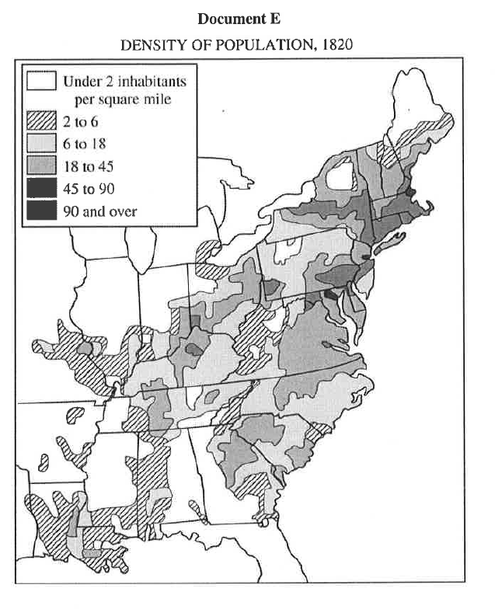
UNITED STATES HISTORY
SECTION II
Total Time-60 minutes

Questions 1 (Document Based Question)
Suggested reading period: 15 minutes
Suggested writing period: 45 minutes

Directions: The following question requires you to construct a coherent essay that integrates your interpretation of Documents A-I and your knowledge of the period referred to in the question. High scores will be earned only by essays that both cite key pieces of evidence from the documents and draw on outside knowledge of the period.

Write your responses on the lined pages that follow the question.

In your response you should do the following.
- State a relevant thesis that directly addresses all parts of the question.
- Support the thesis or a relevant argument with evidence from all, or all but one, of the documents.
- Incorporate analysis of all, or all but one, of the documents into your argument.
- Focus your analysis of each documents on at least one of the following: intended audience, purpose, historical context, and/or point of view.
- Support your argument with analysis of historical examples outside the documents
- Connect historical phenomena relevant to your arguments to broader events of processes.
- Synthesize the elements above into a persuasive essay.

1. Historians have traditionally labeled the period after the War of 1812 the “Era of Good Feelings” due to shared desire for national unity and the decline of partisan disputes. Support, modify, or refute this contention using specific evidence.

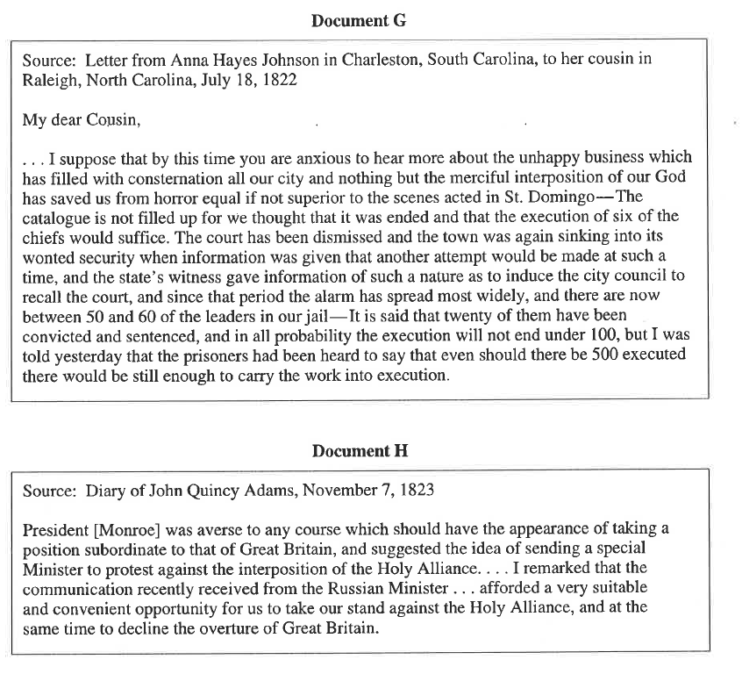

UNITED STATES HISTORY
SECTION II
Total Time-60 minutes

Questions 1 (Document Based Question)
Suggested reading period: 15 minutes
Suggested writing period: 45 minutes

Directions: The following question requires you to construct a coherent essay that integrates your interpretation of Documents A-I and your knowledge of the period referred to in the question. High scores will be earned only by essays that both cite key pieces of evidence from the documents and draw on outside knowledge of the period.

Write your responses on the lined pages that follow the question.

In your response you should do the following.
- State a relevant thesis that directly addresses all parts of the question.
- Support the thesis or a relevant argument with evidence from all, or all but one, of the documents.
- Incorporate analysis of all, or all but one, of the documents into your argument.
- Focus your analysis of each documents on at least one of the following: intended audience, purpose, historical context, and/or point of view.
- Support your argument with analysis of historical examples outside the documents
- Connect historical phenomena relevant to your arguments to broader events of processes.
- Synthesize the elements above into a persuasive essay.

1. Historians have traditionally labeled the period after the War of 1812 the “Era of Good Feelings” due to shared desire for national unity and the decline of partisan disputes. Support, modify, or refute this contention using specific evidence.

