In 1947, the Congress of Racial Equality (CORE) conducted a “Journey of Reconciliation” to direct attention toward racial segregation in public transportation in the Southern U.S.A. Although this initial freedom ride campaign was not regarded as a great success during its time, it inspired the 1961 Freedom Rides that fueled the U.S. Civil Rights Movement.

CORE’s strategy was to take advantage of two new Supreme Court rulings. Boynton vs. Virginia was a court case from 1958 involving a Howard University law student who was arrested for attempting to desegregate the whites-only Trailways bus terminal restaurant in Richmond, Virginia. The Supreme Court overturned Boynton’s conviction and ruled that state laws mandating segregation in waiting rooms, lunch counters, and restroom facilities for interstate passengers were unconstitutional. The ruling also extended an earlier case, Morgan vs. Commonwealth of Virginia, which ruled that legally enforcing segregation on interstate buses and trains was unconstitutional.

Despite these two Supreme Court rulings, in 1961 African Americans were still harassed on interstate buses and facilities were segregated. President John F. Kennedy had just entered the White House and, even though he was preoccupied by the Cold War with the Soviet Union, CORE expected that he could be pressured by nonviolent direct action to enforce the civil rights of African Americans.

Led by CORE Director James Farmer, the first team of thirteen volunteer Freedom Riders left Washington, D.C., on 4 May 1961, heading south. Most of the riders were in their 40s and 50s. Before leaving they got intensive training including role-plays. As an interracial group their intention was to sit wherever they wanted on buses and trains as well as to demand unrestricted access to terminal restaurants and waiting rooms.

The Riders encountered little resistance in Virginia, but some were arrested in North Carolina. They met physical violence in Rock Hill, South Carolina, as well as arrests, and proceeded on to Georgia.

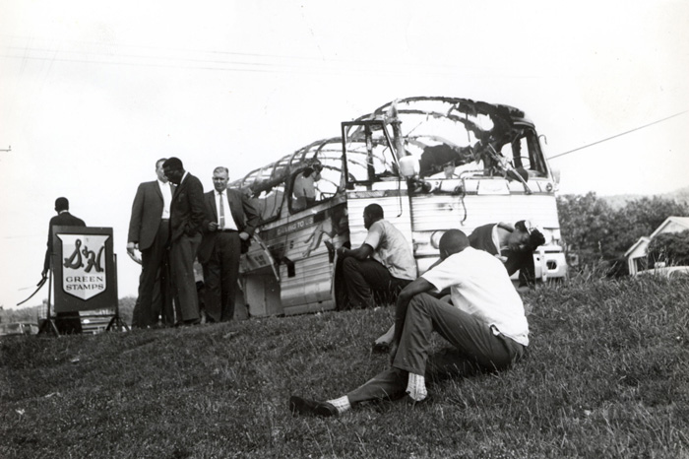
Police in Birmingham, Alabama decided to use violence to stop the campaign when it reached their state and chose Anniston for their first battle. They agreed that the Ku Klux Klan (a white terrorist organization) would be encouraged to attack the activist team. On 14 May, Mother’s Day, a mob of Ku Klux Klansmen attacked the first of the two buses that carried Freedom Riders, slashing its tires, following up by firebombing the bus in the rear. The mob held the front bus door shut, apparently hoping to burn the riders to death, but the Riders were able to escape. As the riders exited the bus they were viciously beaten. Highway patrolmen then appeared to prevent the Riders from being killed.
That night in Birmingham, the hospitalized Riders from the first bus narrowly escaped renewed attacks by a mob.

The second bus, on reaching its stop in Anniston, was boarded by eight Klansmen who beat the Freedom Riders and left them semi-conscious. The bus continued on to Birmingham, where it was again attacked at the bus terminal by a mob with baseball bats, iron pipes and bicycle chains. One member of the mob was an FBI informant.

When US Attorney General Robert Kennedy was informed of the bus burning and beatings, he urged CORE to exercise restraint. Refusing the advice, the Freedom Riders decided to continue on to Montgomery where another mob waited for them; at that point, however, bus drivers refused to drive them anywhere.

In Nashville, Tennessee, where a major black student-led sit-in campaign had previously achieved victory, leader Diane Nash organized fellow members of the Student Nonviolent Coordinating Committee (SNCC) to continue the Freedom Ride that was stalled in Birmingham. A new set of ten Riders took the bus from Nashville to Birmingham where they were promptly arrested and jailed by Police commissioner Bull Connor.

Despite howling mobs around the Birmingham bus station, additional SNCC members were able to get on a bus on May 20 and head toward Montgomery at 90 miles an hour accompanied by the Alabama Highway Patrol. Once in Montgomery the Highway Patrol left them and they were beaten with baseball bats and iron pipes by a white mob. Ambulances were called but refused to take the wounded to the hospital. The riders were rescued by local blacks.

Late that night a mob of thousands of whites surrounded a black church in Montgomery where the Freedom Riders and locals were holding a meeting. As the mob began to attack the church, the black citizens, led by Dr. Martin Luther King, Jr., responded with prayer and hymns. King attempted to address the white mob but returned to the church after being showered with bricks.

In the meantime, more volunteers arrived in Montgomery from CORE and SNCC to continue the rides. Faced with the campaign’s continuing against the Kennedys’ advice, the U.S. administration apparently felt forced to intervene, gaining promises from the governors of Alabama and Mississippi to reduce the level of mob violence, although the agreement allowed the governors to continue to arrest the Freedom Riders – in violation of federal law.

On 24 May the Freedom Riders continued on toward Jackson, Mississippi, where they were arrested when they tried to use the white-only facilities in the bus terminal. Some Freedom Riders left behind in Montgomery were arrested for violating local segregation laws.

The Kennedys again asked for a “cooling off period” and showed no intention of enforcing the Supreme Court’s view of black rights. The organizations now backing the campaign—CORE, SNCC, and the Southern Christian Leadership Conference (SCLC)—decided to defy the Kennedys and continue the campaign throughout the summer if need be. During June, July, August, September more than 60 Freedom Rides traveled across the South, most of them ending in Mississippi.

The riders who got to Jackson were arrested -- more than 300 in total (out of an estimated total of 450 riders in all). Most of the activists were male, under 30, and about evenly divided between black and white. Once arrested most riders staged a “jail-in” rather than use a provision for bail or fines; their strategy was to fill the jails and state prisons, stressing the treasury of the state of Mississippi.

The white-owned national mass media mostly presented a negative image of the Riders and editorials condemned the Freedom Rides through the long, hot summer. Despite this, there was increasing criticism expressed internationally toward the federal unwillingness to enforce the law. The expanding campaign of direct action increased the pressure on the states and the federal government.

As U.S. Attorney General Robert Kennedy was the chief law enforcement official in the nation, he eventually found a legal mechanism he could use to end the campaign, pressing the Interstate Commerce Commission (ICC) to enforce integration.

The new ICC policy took effect 1 November. Black passengers could sit anywhere on buses, trains, or terminal lunch counters. “White” and “colored” signs were removed from the toilets and drinking fountains. African Americans living in states still dominated by the Ku Klux Klan and White Citizens Councils began to envision major change and prepare for the campaigns of the future. They had seen that, regardless of the intimidation and violence directed towards the Freedom Riders, the activist teams had all continued to defy segregation with a nonviolent discipline. The riders sang songs, made signs, and refused to move even though facing arrest, assault, and possible death.

Three years after the first Freedom Ride, the U.S. Civil Rights Act of 1964 was passed, outlawing segregation in public facilities in all parts of the United States.

