Images of hate: Nazi and Confederate flags in defeat faced different fate
By McClatchy Washington Bureau, adapted by Newsela staff
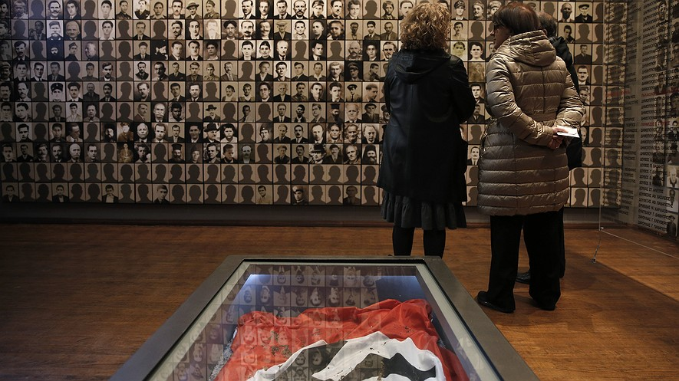
BERLIN, Germany — The Nazi flags were torn down while defeated German cities still burned. World War II had just come to an end and Germans were only starting to realize the Nazi government was no more.
Nazi Germany ceased to exist in 1945. Eighty years earlier, in 1865, another war, the Civil War, brought an end to the Confederate States of America, the breakaway would-be nation formed by the slave-owning Southern states. What ended up happening to the symbols of the two governments differed greatly, however.

For most Germans the swastika recalls the Nazi state's murder of 6 million Jews and 5 million others. It reminds them of Germany's role in causing a world war that killed up to 70million people. Nazi symbols are almost never seen outside of a museum, where they are presented in a way that is highly critical of Nazism.
The conquering Allies banned the display of Nazi symbols in October 1945. The newFederal Republic of Germany enshrined that ban in German law in 1949.

Reminders Of Nazi Era Were Destroyed
After 1945, almost everything that would remind people of the Nazis was destroyed. Unmarked graves became the norm for Nazi officials. Chiseled swastikas were ground off buildings and monuments and statues were torn down.
Until recently, the spot where Nazi leader Adolf Hitler killed himself was left as an unmarked parking lot. Spandau Prison, a Berlin jail that housed high-ranking Nazis after the war, was torn down to prevent it from becoming a holy place for modern Nazis. Officials went so far as to smash the bricks to bits. Then they threw the remains into the North Sea.
Things turned out very differently for the Confederate battle flag. It found its way into cemeteries and flag stands and even became part of some official state flags. The flag itself would fly over statehouses in several former Confederate states.
Deidre Berger is director of the American Jewish Committee office in Berlin. She notes that it is difficult to compare anything to the Holocaust, the mass killing carried out by the Nazi state that took 6 million Jewish lives. However, she said, the symbols of the Holocaust and of slavery both represent intense hatred.
“They’re symbols of a way of life that is completely unacceptable,” she said. Germans realized that the only way to once again become a nation worthy of respect was to get rid of all Nazi-era symbols. "Banning them was appropriate," she said. "Americans made a different choice with the symbols of the Confederacy.”

Symbols Important For Hate Groups
She said the ban in Germany has been important. It protects the victims and children of victims from a constant reminder of past horrors. Beyond that, she noted, “the symbols serve as a rallying point for all hate groups.” Banning them helps prevent them from being used to fan hate in Germany.
“It’s important not to underestimate the power of symbols,” she said.
Mark Potok studies hate groups in the United States. “Symbols are important," he said. "They’re a shorthand groups use in a single image to convey a world of information.” Potok notes that some Southern states took to flying the battle flag in the 1960s to symbolize their resistance to allowing blacks into all-white schools.
Potok hailed South Carolina for recently voting to remove the Confederate flag from all official buildings. However, he added, "you could argue it was 150 years late.”

Swastika Used At White-Power Events
It is notable that both the battle flag and the Nazi swastika could be seen at pro-Confederate flag rallies held in South Carolina. In recent years the two flags often appear together at white-power gatherings.
“Those who fly both flags rely on horribly distorted versions of history,” said Potok. “They both say that the Civil War wasn’t about slavery, and that the Holocaust was exaggerated, or didn’t happen.”
Just how many human beings were enslaved in the United States is a much debated topic. Records show that around 450,000 Africans were kidnapped in Africa and brought to what became the United States. However, there were generations of children born to those captives and the members of each successive generation were slaves as well. All told, Southern slaves numbered in the millions. By the time the Confederacy fell in 1865, the number of people who had been held as slaves roughly equaled the 11 million murdered by Nazi Germany.

German Students Must Learn About Holocaust
Confederate flag supporters focus on what they say was good about life in the South during the antebellum, pre-Civil War years. By contrast, German students spend a part of each year studying the horrors of Nazi Germany. All students must visit at least one of the concentration camps where Jews were killed. The goal is to remind students that the stories of the Holocaust are not only real but happened nearby.
In Germany, wearing or publicly displaying Nazi symbols can result in up to three years in prison.
German historian Paul Nolte said there are several reasons why Nazi symbols disappeared from the country. Early on, people just wanted to forget the war.

