Essential Question: Was the Market Revolution a positive or negative change?

Bentley, Elizabeth and Frank Forrest. Sadler Committee Testimonials Michael Sadler. 4 June 1832.

The following are testimonials from employees at the Wilson Mill in Bedford, Massachusetts.

Elizabeth Bentley:
“I worked from five in the morning till nine at night. I lived two miles from the mill. We had no clock. If I had been too late at the mill I would have been quartered. I mean that if I had been a quarter of an hour too late a half an hour would have been taken off. I only got a penny an hour and they would have taken a halfpenny.”

Frank Forrest
“In reality there were no regular, hours masters and managers did with us as they liked. The clocks in the factories were often put forward in the morning and back at night. Though this was known amongst the hands we were afraid to speak and a workman then was afraid to carry a watch.”

H

A

P

P

Y

Essential Question: Was the Market Revolution a positive or negative change?

Herbergam, Joseph. Testimony of a Textile Worker Michael Sadler. 1 July 1832.

The following is an excerpt from the testimony of textile worker Joseph Hebergam to the Sadler Committee.
Sadler: What is the nature of your illness?
Hebergam: I have damaged lungs. My leg muscles do not function properly and will not
support the weight of my bones.
Sadler: A doctor has told you that you will die within the year, is that correct?
Hebergam: I have been so told.
Sadler: Did he tell you the cause of your illness?
Hebergam: He told me that it was caused by dust in the factories and from overwork and
insufficient diet.
Sadler: To what was your brother's death attributed?
Hebergam: He was cut by a machine and died of infection.

H

A

P

P

Y

Essential Question: Was the Market Revolution a positive or negative change?

Knight, Charles. "The Results of Machinery, Namely Cheap Production and Increased Employment." The Working Man's Companion. Birmingham: Beibly, Knott, and Beibly, 1831.

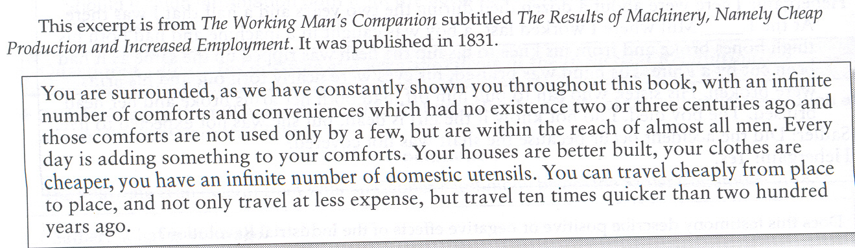
H

A

P

P

Y
Essential Question: Was the Market Revolution a positive or negative change?

Average Wages for Children
"Leaving the Mills." Leaving the Mills. N.p., n.d. Web. 05 Nov. 2012.
<http://web.bryant.edu/~ehu/h364proj/summ_99/hutchinson/leaving.html>.
Work | Female Wage | Rent | Allowance ($ able to keep)* | Male Wage (Kept their earnings)
Factory | $.44 - $1.58 per day | $1.25 per week | $1.00 per week | $.88 - $3.16 per day
Domestic Work | $.50 per week | N/A | N/A | N/A
*Remaining money was sent home to family for bills, financing brother’s education, dowry, etc.

H

A

P

P

Y

Essential Question: Was the Market Revolution a positive or negative change?

This following is a letter by a factory worker to a newspaper in Lowell, Massachusetts (1834).
We must leave our looms. We are daughters of free men and are being forced to work under conditions that approach slavery. Do we need this money so badly that we will submit to these inhumane working conditions while this aristocracy of mill owners lives off the profits of our sweat? Are we not entitled to reasonable breaks in our toil to eat our meals as decent people do - not racing to our boardinghouses and bolting our food like piglets at the trough? And is it not reasonable to limit the workday to ten hours so we have time in the evenings to improve our minds as we were promised? WE must prevent our sex from being made into living machines to do the bidding of incorporated aristocrats and reduced to a sum for their services hardly sufficient to keep soul and body together. The mill managers have been deaf to our petitions and our rallies. They will only hear us when the factories are stilled by workers leaving their looms to secure their dignity and their rights.
A Factory Operative

H

A

P

P

Y

