Mayflower Compact
Directions: As you read through the Mayflower Compact, highlight words that reflect American values and identity today in one color. In a different color, highlight values of the Pilgrims that are no longer part of American values.
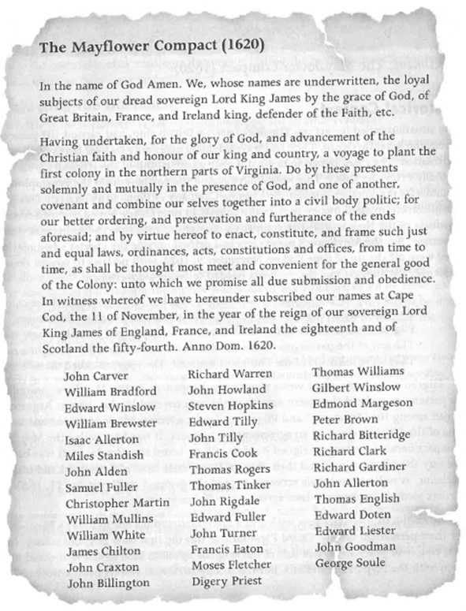

What elements of the Mayflower Compact are reflected in American identity today?

Pick one specific value highlighted in the Mayflower Compact that is reflect in American identity today. Does America live up to this value today? Provide some specifics as to why or why not?

____________________________________________________________________________________
____________________________________________________________________________________________________________________________________________________________________________________________________________________________________________________________________________________________________________________________________________________________________________________________________________________________________________________________________________________________________________________________________________________________________________________________________________________________________________________________________________________________________________________________________________________________________________________________________________________________________________________________________________________________________________________________________________________________________________________________________________________________________________________________________________________________________________________________________

Based on these elements, why is the Mayflower Compact significant in US History?
________________________________________________________________________________________________________________________________________________________________________________________________________________________________________________________________________________________________________________________________________________________________________________________________________________________________________________________________________________________________________________________________________________________________________________________________________________________________________________________________________________________________
________________________________________________________________________________________________________________________________________________________________________

