Mexican-American War

Essential Question: Was the United States justified in going to war with Mexico?

America’s wars have often been controversial. The American Revolution had the support of only one-third of the American colonists. The War of 1812 caused several New England states to threaten secession. Entry into World War I was vigorously opposed. More recently, Vietnam, and then Iraq, divided the nation. It should come as no surprise, then, that America’s war with Mexico had both its supporters and its critics.

In 1821, Mexico declared itself free from its mother country, Spain. Mexico was huge. It stretched from Guatemala to Oregon and was equal in size to the United States. Mexican leaders were aware of the near emptiness of their northern lands. One way to increase the population was to welcome settlers from the United States. A special effort was made to encourage American farmers to settle in the Mexican province of Texas.

For Mexico, this turned out to be a bad idea. Mexico was Catholic, anti-slavery, and wanted to keep Texans under their control. The American settlers were mostly, Protestant, pro-slavery, and largely ignored Mexican authority. It did not take long for these differences to boil into revolt. Following bloody encounters at places like the Alamo, the Texans won their independence from Mexico in 1836.

Two times over the next nine years, Texas applied to the United States Congress for annexation. Both times Congress said “no.” Some Congressmen did not want to anger Mexican officials who still regarded Texas as part of their country. Other Congressmen, especially in the Northeast, did not want a large slave territory to be added to the United States.

Then things changed. In late 1844, James K. Polk was elected President of the United States. Polk was a strong supporter of Manifest Destiny. He believed it was God’s plan that America extend its territory all the way to the Pacific Ocean. Polk did not just want to annex Texas. He also had his eye on California.

After Polk’s election, but before he took office, Congress reversed itself and voted to annex Texas. Polk was delighted. In July 1845 he sent American troops under General Zachary Taylor into the disputed area of southern Texas. He also sent John Slidell, a special envoy, to Mexico City to try to buy California. The combination of American troops at the Rio Grande and the attempt to buy a large part of their country angered the Mexican government. Slidell was asked to leave Mexico City.

Polk saw Mexico’s treatment of Slidell as an opportunity. He felt America’s honor had been challenged. When word arrived on May 9, 1846, that Mexican soldiers had fired upon Americans on the “Texas side” of the Rio Grande, President Polk had a reason for going to war.

Essential Question: Was the United States justified in going to war with Mexico?

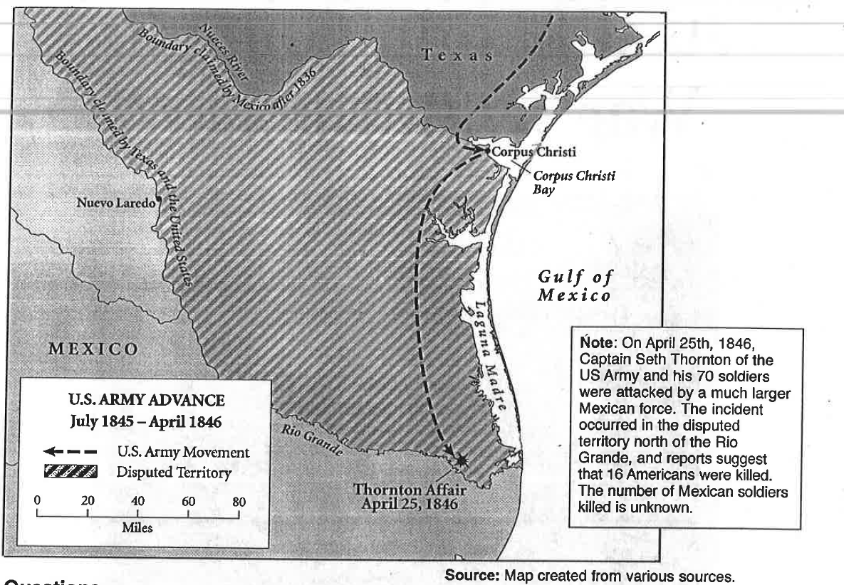

Circle the element of HAPP that is most relevant, then complete that element of HAPP and Y.

Historical Background | Audience | Point of View | Purpose
Y- Significance

Essential Question: Was the United States justified in going to war with Mexico?

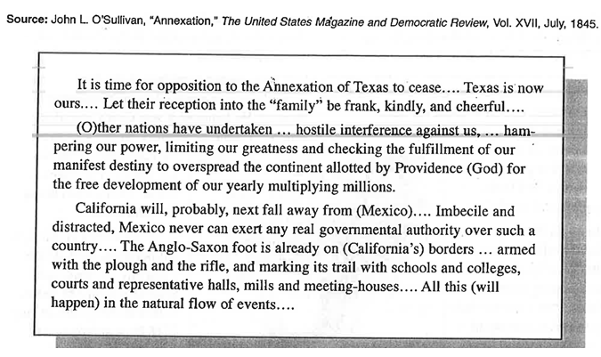

Circle the element of HAPP that is most relevant, then complete that element of HAPP and Y.

Historical Background | Audience | Point of View | Purpose
Y- Significance

Essential Question: Was the United States justified in going to war with Mexico?

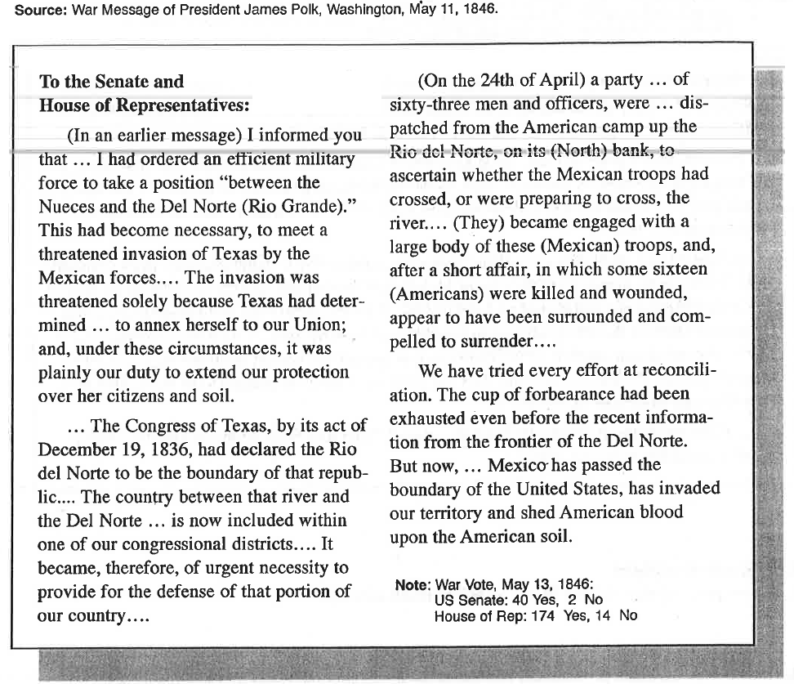
Historical Background | Audience | Point of View | Purpose
Y- Significance

Essential Question: Was the United States justified in going to war with Mexico?
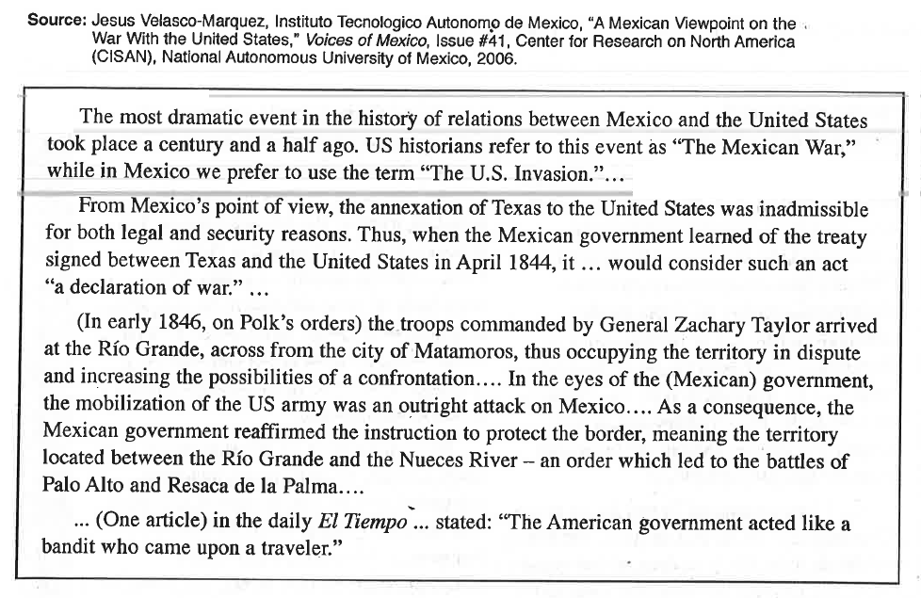

Circle the element of HAPP that is most relevant, then complete that element of HAPP and Y.

Historical Background | Audience | Point of View | Purpose
Y- Significance
Essential Question: Was the United States justified in going to war with Mexico?

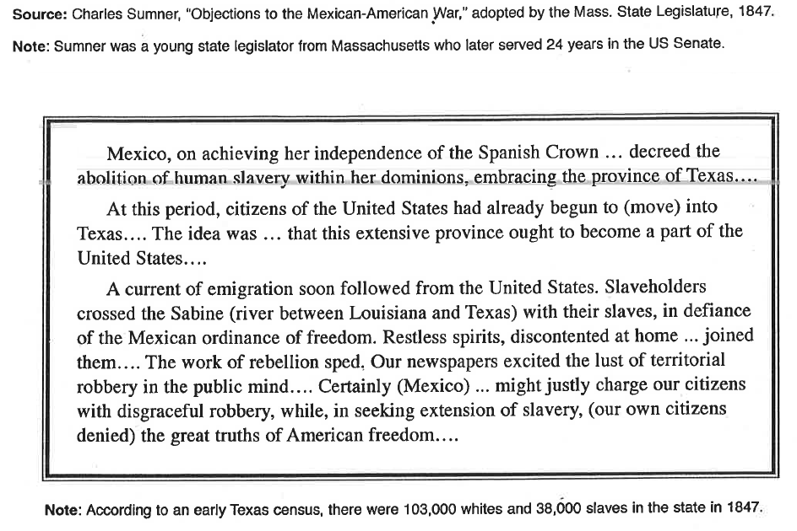
Circle the element of HAPP that is most relevant, then complete that element of HAPP and Y.

Historical Background | Audience | Point of View | Purpose
Y- Significance

