The Anasazi: Chaco Canyon and Mesa Verde

The great urban centers of Peru and Mesoamerica had no counterparts farther north. The peoples inhabiting North America in the millennium before Columbus never developed the levels of social stratification, urban dynamism, architectural grandeur, astronomical study, or intensive corn agriculture that characterized the Mayans, Incas, or Aztecs. Yet elements of all these traits appeared in North America, especially in the Southwest and the Mississippi valley, with the emergence of increasingly settled societies and widening circles of exchange.

Modern scholars wonder whether the maize, squash, and bean agriculture, sun worship, and astronomical knowledge found among North America’s southwestern peoples had roots farther south. After all, the Aztecs’ ancestors had apparently migrated down from this dry region to the interior of Mexico after a.d. 1100. Could other north–south movements back and forth have occurred, earlier or later, between Central Mexico and the American Southwest? Links of migration or trade would help to explain the dozens of ancient ball courts, similar to those in Mesoamerica that archaeologists have excavated in Arizona. Recently, researchers have identified a north–south traffic in turquoise, highly prized in both Mexico and the Southwest.

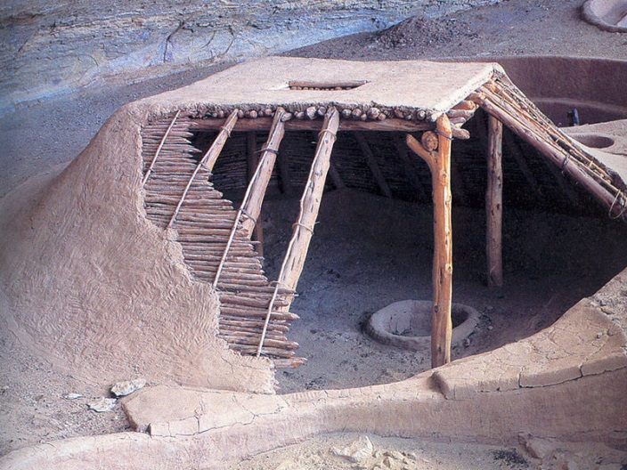
Three identifiably different cultures were already well established in the North American Southwest by a.d. 500. The Mogollons occupied the dry, mountainous regions of eastern Arizona and southern New Mexico. Mogollon women were expert potters who crafted delicate bowls from the fine clay of the Mimbres River. Families lived in sunken pit houses that were cool in summer and warm in winter.

The Hohokams, their neighbors to the west in south-central Arizona, did the same. The Hohokams also constructed extensive canal and floodgate systems to irrigate their fields from the Gila and Salt rivers. According to their Native American successors, who still dwell in the Phoenix area, the name Hohokam means “those who have gone.”

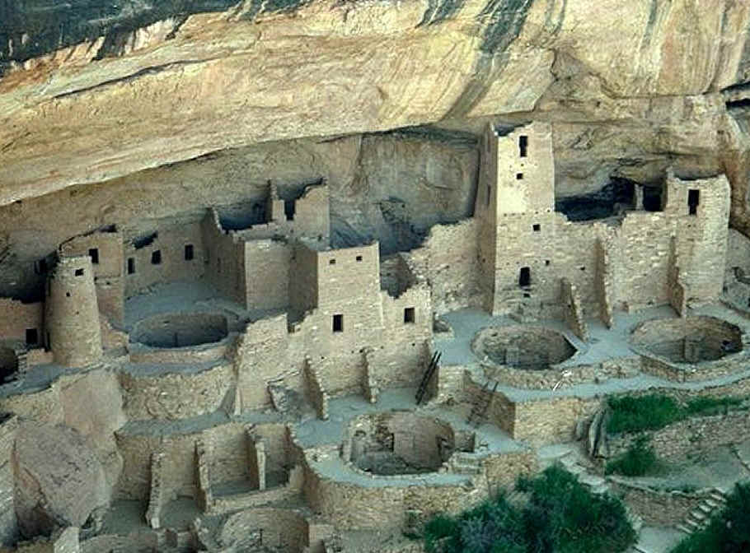
Farther north, in what is now the Four Corners Region, where Utah and Colorado meet Arizona and New Mexico, lived the people remembered as the Anasazi, or “ancient ones.” By a.d. 50 the Anasazi inhabited aboveground houses clustered around a central ceremonial room dug into the earth. They entered this circular space by descending a ladder through the roof. The climb back up from this sunken chamber, known as a kiva, symbolized the initial ascent of humans into the Upper World from below. European explorers used the Spanish word for town, pueblo, to describe the Anasazis’ multiroom and multistory dwellings of masonry or adobe.

Beginning in the 850s, Chaco Canyon in the San Juan River basin of northwest New Mexico emerged as the hub of the Anasazi world. Wide, straight roads radiating out from Chaco let builders haul hundreds of thousands of logs for use as roof beams in the nine great pueblos that still dot the canyon. The largest of them, Pueblo Bonito, rises five stories high in places and has 600 rooms arranged in a vast semicircle. Yet the canyon’s population remained small, perhaps dominated by priestly rulers who used violence to extract labor, food, and tribute from the region’s inhabitants.

Violence and warfare played a significant part in Anasazi life, as they did in the Mesoamerican world of the same era. But in the end, environmental change exerted the greatest destructive force. Tree rings show that after 1130, a drought gripped the Colorado Plateau for half a century. The turquoise workshops of Chaco Canyon fell silent. Most of the inhabitants moved away. Some no doubt headed north, where dozens of Anasazi communities with access to better farming conditions dotted the landscape. Earlier, they had resided atop mesas (from the Spanish word meaning “table,” for the region’s distinctive hills with steep sides and level tops). But gradually—with populations growing, the climate worsening, and competition for resources stiffening—they moved into sheltered cliff dwellings built into the mesa walls. Cliff Palace at Mesa Verde in southwestern Colorado, with its 220 rooms and 2kivas, remains the most famous today because of its ready access and careful preservation. Yet other sites were even larger. Reached only by ladders and steep trails, these pueblos offered protection from enemies and shelter from the scorching summer sun. Still, another prolonged drought (12–12) forced the Anasazi to move once again by 1300. Survivors dispersed south into lands later occupied by the Hopi, Zuni, and Rio Grande peoples.

Wood et al., 13–15.

The Mississippians: Cahokia and Moundville

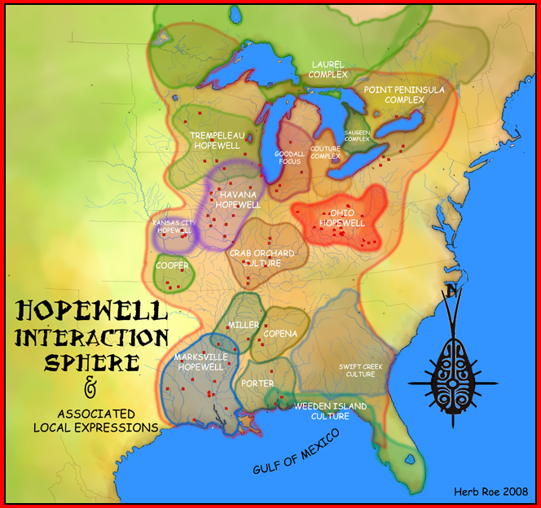
Earlier, in the Mississippi Valley, the Hopewell people had prospered for half a millennium before a.d. 500 (in the era of the Roman Empire in Europe). The Hopewell lived primarily in southern Ohio and western Illinois. But their network of trade extended over much of the continent. Archaeologists excavating ornate Hopewell burial sites have found a wide array of objects, including pipestone and flint from the Missouri River Valley, copper and silver from Lake Superior, mica and quartz from Appalachia, sea shells and shark teeth from Florida, and artwork made from Rocky Mountain obsidian and grizzly-bear teeth. Hopewell trading laid the groundwork for larger mound-building societies, known as the Mississippian cultures that emerged in the Mississippi Valley and the Southeast in roughly the same centuries as the great Mesoamerican civilizations and the Anasazi in the Southwest.

The more elaborate and widespread Mississippian tradition developed gradually after a.d. 500. Then after a.d. 900, it flourished broadly for six centuries. Shifts in technology and agriculture facilitated the rise of the Mississippians.

Bows and arrows, long used in arctic regions of North America but little known elsewhere, began to see widespread use in the eastern woodlands around a.d. 700. At the same time, maize underwent a transformation from a marginal oddity to a central staple crop. Growers as far east as northern Florida were producing it by the eighth century, and it soon appeared farther north with the spread of a more hardy variety. By 1300, maize and bean agriculture reached all the way to the Iroquoian peoples around Lake Ontario and in the St. Lawrence River valley. Across the east, food supplies expanded as Native American communities planted corn in the rich bottomland soil along the region’s many rivers. More and more people began settling in these fertile areas. Maize agriculture also spurred bureaucracy and hierarchy. With greater productivity, commercial and religious elites asserted greater control over farmers to take advantage of the community’s expanding resources.

The extent of contacts, rivalries, and exchanges between separate Mississippian mound-building centers remains uncertain. Mississippian sites have been found as far apart as Spiro, in eastern Oklahoma, and Etowah, in northern Georgia. The largest complex was at Cahokia in American Bottom, the 25-mile floodplain below where the Illinois and Missouri rivers flow into the Mississippi. We will never know Cahokia’s full extent, for city planners expanding St. Louis in the nineteenth century flattened more than two dozen mounds on the Mississippi’s west bank, leaving little record of their work.

Across the river, builders in East St. Louis, Illinois, and farmers eager to increase their acreage leveled more mounds. But nearby, on Cahokia Creek, dozens of rectangular, flat-topped temple mounds still remain after almost a thousand years. The largest mound at Cahokia—indeed, the largest ancient earthwork in North America—rises 100 feet in four separate levels, covering 16 acres and using nearly 22 million cubic feet of earth. A log palisade with gates and watchtowers once enclosed this temple mound and its adjacent plaza in a 200-acre central compound. In a separate construction nearby, residents used engineering and astronomy skills to erect 48 posts in a huge circle, 410 feet in diameter. This creation, now called Woodhenge after England’s Stonehenge, functioned as a calendar to mark the daily progression of the sun throughout each year.
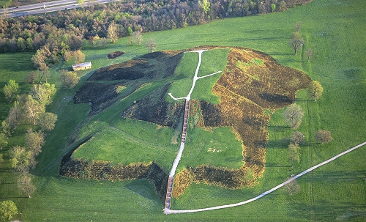
Cahokia’s mounds rose quickly in the decades after a.d. 1050, as the local population expanded beyond 10,000. A succession of powerful leaders reorganized the vicinity’s small, isolated villages into a strong regional chiefdom that controlled towns on both sides of the river. These towns provided the chiefdom’s centralized elite with food, labor, and goods for trading. The elaborate religious rituals and the wealth and power of the leaders are seen in a burial site opened by archaeologists in the 1970s. The body of one prominent figure, presumably a chief, was laid out on a surface of 20,000 shell beads. Near him lay six young adults who must have been relatives or servants sacrificed at the ruler’s funeral. They were supplied with hundreds of stone arrowheads—finely chipped and neatly sorted—plus antler projectile points, a rolled tube of sheet copper, bushels of glistening mica (a transparent mineral crystallized into very thin sheets), and 15 stone disks used in the popular spear-throwing game known as chunkey. Archaeologists found further evidence of sacrifice nearby. They uncovered the remains of four men, whose heads and hands had been cut off, and a pit filled with nearly four dozen young women who apparently had been strangled.

The population of Cahokia perhaps exceeded 15,000 people around a.d. 1100. It then waned steadily over the next two centuries as the unstable hierarchy lost its sway over nearby villages. As Cahokia declined, other regional chiefdoms rose along other rivers. The most notable appeared at Moundville in west-central Alabama, 15 miles south of modern Tuscaloosa. A century of archaeological work at this site has revealed clear phases of development after a.d. 900. First, the inhabitants adopted corn agriculture. This in turn allowed them to intensify craft production, and a budding elite emerged. Before long, the leaders directed the creation of mounds in several small villages. Shortly before 1250, workers laid out an 80-acre rectangular plaza at the Moundville site. They began construction on more than 20 flattopped mounds (some larger than football fields), which provided dwelling sites and burial locations for the small ruling class. Excavated burial objects— ceremonial axes, beads carved from conch shells, and distinctive copper spools worn as giant earrings—reveal evidence of long-distance trade and elaborate rituals. But by 1400, Moundville had started to lose its grip as a dominant ceremonial center. The causes of this decline remain unclear, but once again small villages became the norm.

Wood et al., 15–17.

The Iroquois

Far to the north of the declining southeastern mound-building societies, Iroquoian-speaking people were following a contrary path for several centuries before the arrival of Europeans. The most important of those that were beginning a process of growth and consolidation were the Iroquois. Their territory stretched from the Adirondack Mountains to the Great Lakes and from what is now northern New York to Pennsylvania. Five tribes comprised what Europeans later called the League of the Iroquois: the Mohawk (“People of the Flint”), Oneidas (“People of the Stone”), Onondagas (“People of the Mountain”), Cayugas (“People at the Landing”), and Senecas (“Great Hill People”). The Iroquois confederation was a vast extension of the kinship group that characterized the northeastern woodlands pattern of family settlement and embraced perhaps 10,000 people at the time Europeans began to build settlements in the northeastern region of the continent in the sixteenth century. Living across major Indian trade routes in the Northeast, they were positioned between what would become French and English zones of settlement, which would ensure that the Iroquois would be deeply caught up with the onrush of Europeans.

Not long before Europeans began coming ashore in eastern North America, the loosely organized and strife-ridden Iroquois strengthened themselves by creating a more cohesive political confederacy. By learning to suppress intra-Iroquois blood feuds, villages gained stability, population increased, and the Iroquois developed political mechanisms for solving internal problems and presenting a more unified front in parlaying with their Algonquian neighbors for the use of hunting territories to the north or in admitting dependent tribes to settle on their territory. This facilitated the development of a coordinated Iroquois policy for dealing with the European newcomers.

Work in the palisaded villages of Iroquoia, some bustling with more than a thousand people, was performed communally and land was owned not by individuals but by all in common. An individual family might till their own patch of land, but it was understood that this usage in no way implied private ownership. Likewise, hunting was a communal enterprise. Though individual hunters differed in their ability to stalk and kill deer, the collective bounty of the hunting party was brought back to the village and divided among all. Similarly, several families occupied a longhouse, but the house itself, like all else in the community, was common property. “No hospitals [poorhouses] are needed among them,” wrote a French Jesuit in 1657, “because there are neither mendicants nor paupers as long as there are any rich people among them.

Their kindness, humanity, and courtesy not only makes them liberal with what they have, but causes them to possess hardly anything except in common. A whole village must be without corn, before any individual can be obliged to endure privation.” One historian has called this “upside down capitalism,” where the goal was not to pile up material possessions but to reach the happy situation where they could give what they had to others.

Out of extended kinship groups, the Iroquois organized village settlements. Like many Africans, the Iroquois had matrilineal families where family membership was determined through the female rather than male line. A typical Iroquois family comprised an old woman, her daughters with their husbands and children, and her unmarried granddaughters and grandsons. Sons and grandsons remained with their kinship group until they married; then they joined the family of their wife or the family of their mother’s brother. If this puzzled Europeans, whose men controlled women strictly, so did the Iroquois woman’s prerogative of divorce; if she desired it, she merely set her husband’s possessions outside the longhouse door.
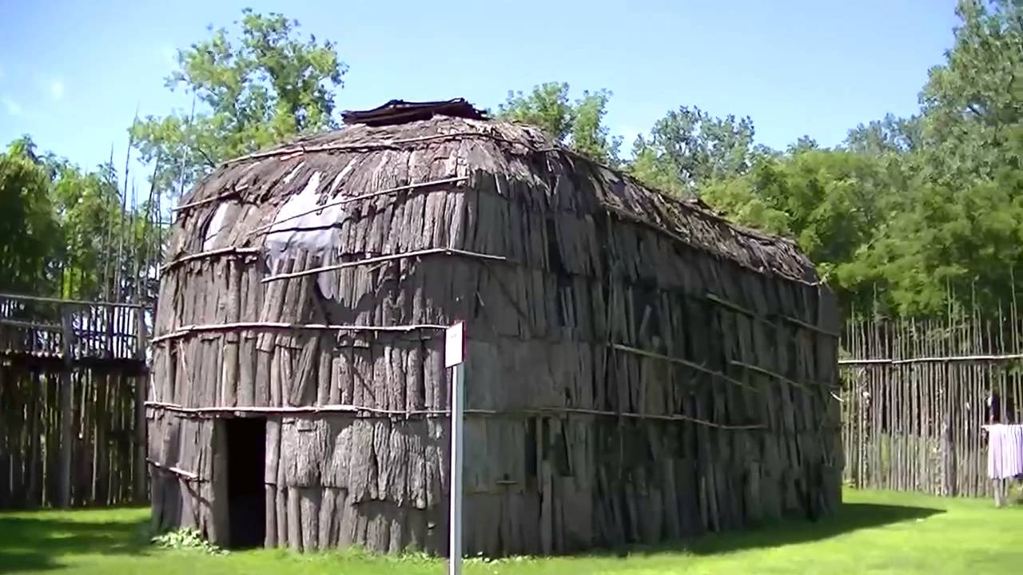
Iroquois society also invested the community’s women with a share of political power in ways the Europeans found strange. Political authority in the villages derived from the matrons or senior women of the ohwachiras—a group of related families. These women named the men representing the clans at village and tribal councils and appointed the sachems or chiefs who met periodically when the confederated Five Nations met. These civil chiefs were generally middle-aged or elderly men who had gained fame earlier as warriors but now gained their prestige at the council fires. The political power of the women also extended to the ruling councils, where they caucused behind the circle of chiefs and made sure that the tribal council did not move too far from the will of the women who appointed them. The male chiefs were secure in their positions only so long as they could achieve a consensus with the women who had placed them in office.

Power divided between men and women was seen further in the tribal economy and in military affairs. While men did most of the hunting and fishing, the women were the community’s primary agriculturists. In tending the crops, they became vital to sustaining the community. When men were away on weeks-long hunting expeditions, women were left entirely in charge of village daily life. If “the forest belonged to the men,” one historian explains, “the village was the woman’s domain.” In military affairs women played a significant role, for they supplied the moccasins and food for warring expeditions. A decision to withhold these supplies was tantamount to vetoing a military foray. Clan matrons often initiated war by calling on the Iroquois warriors to bring them enemy captives to replace fallen clan members.
In raising children, Iroquois parents were more permissive than Europeans. They did not believe in harsh physical punishment, encouraged the young to imitate adult behavior, and were tolerant of fumbling early attempts. The mother nursed and protected the infant while hardening it by baths in cold water. Weaning ordinarily began at age three or four. Childhood interest in the anatomy and in sexual experimentation was accepted as normal. All this contrasted with European child-rearing techniques, which stressed accustoming the child to authority from an early age through frequent use of physical punishment, condemning early sexual curiosity, and emphasizing obedience and respect for authority.
The approach to authority in Iroquois society, like most other Indian societies in North America, lacked most of the complicated machinery developed by Europeans to direct individual lives. No laws and ordinances, sheriffs and constables, judges and juries, or courts or jails—the apparatus of authority in Europe—existed in pre-contact North America. Yet the Iroquois set boundaries of acceptable behavior firmly. They prized the autonomous individual yet maintained a strict code of right and wrong. But they governed behavior by imparting a sense of tradition and attachment to the group through communally performed rituals. Europeans dealt with crime through investigation, arrest, prosecution, and sentencing. But in Indian society, those who stole food, to take one example, were “shamed” and ostracized until the culprits atoned for their actions and proved ready for re-entry into village communal life.

Nash et al., 16–18.

