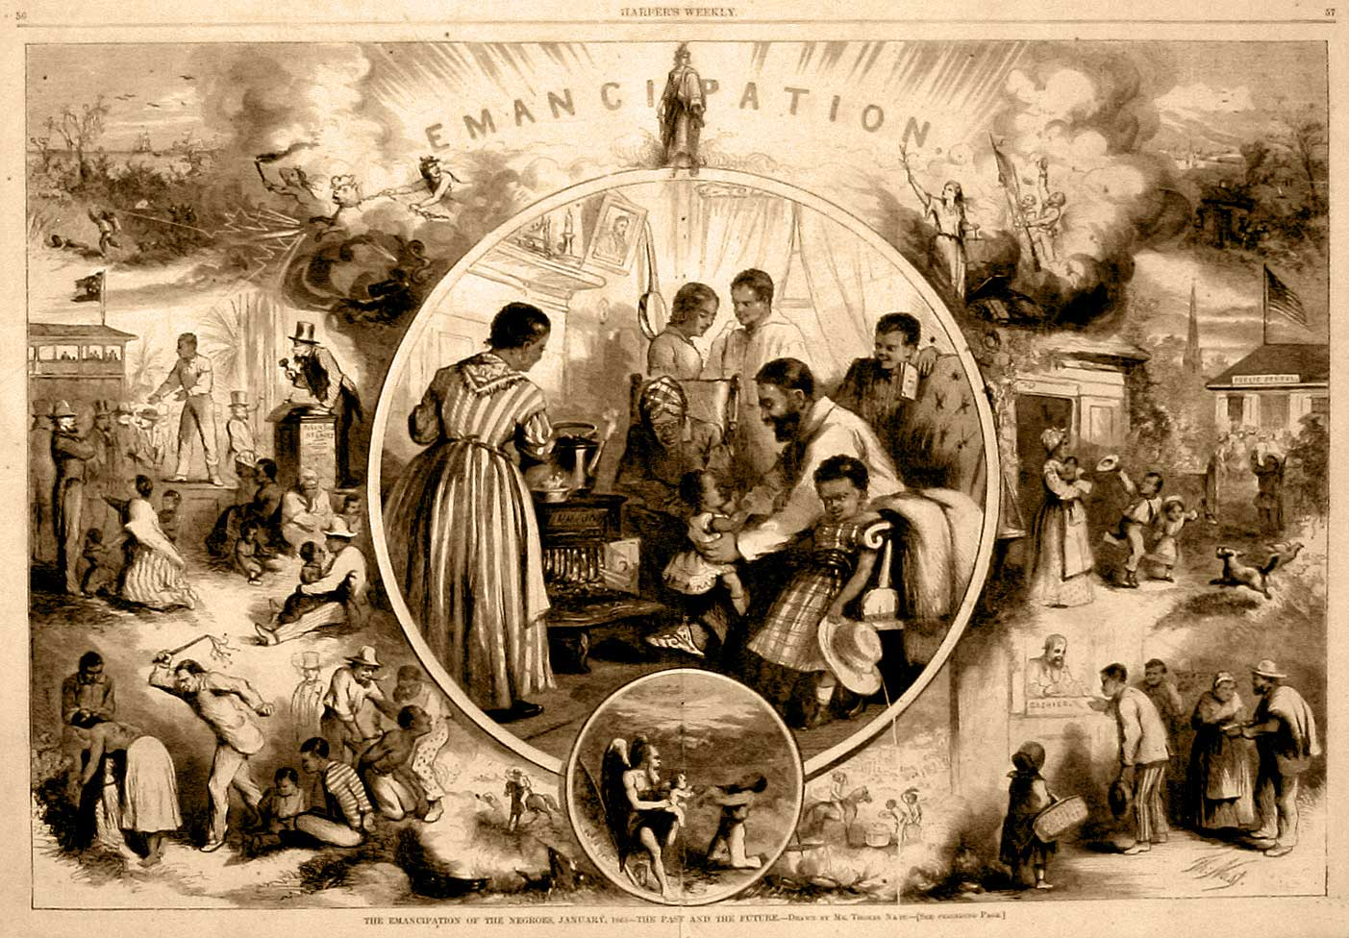**Emancipation**

**The Hope for the 15th Amendment**

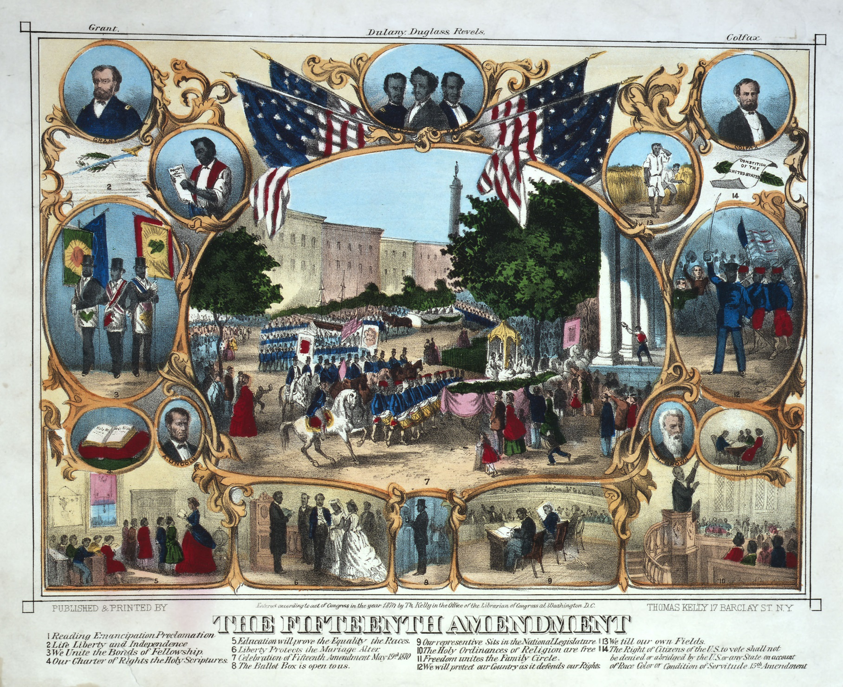

**The First Vote**

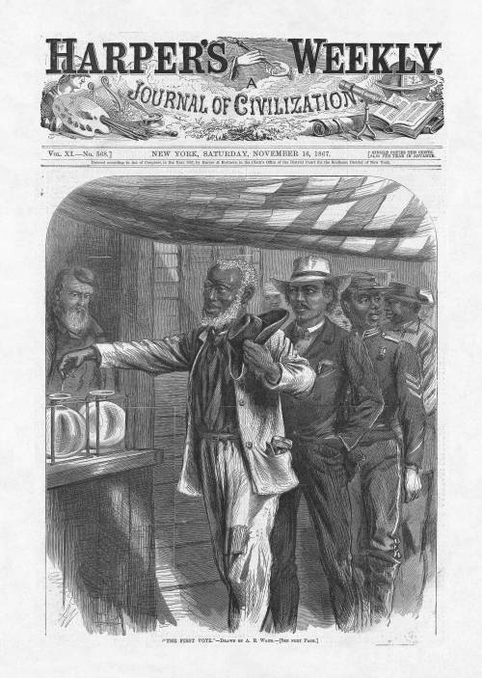

**The First Colored Senator and Representatives**

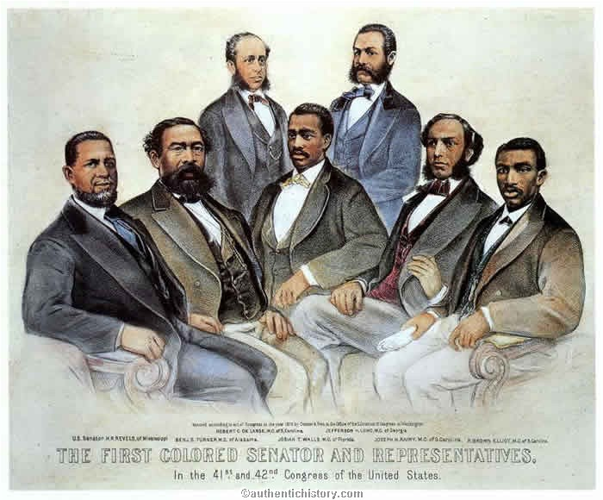

**Save the Union**

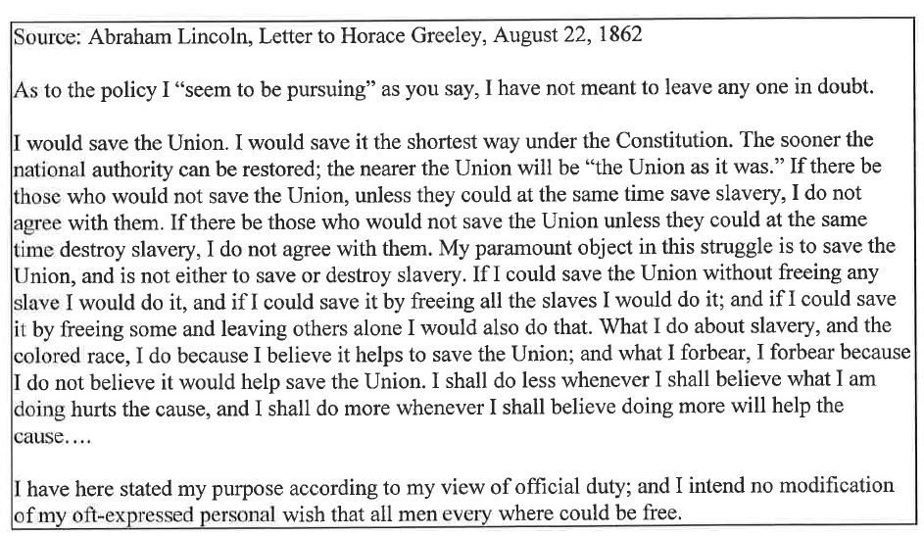

**Sea Island Experiment**

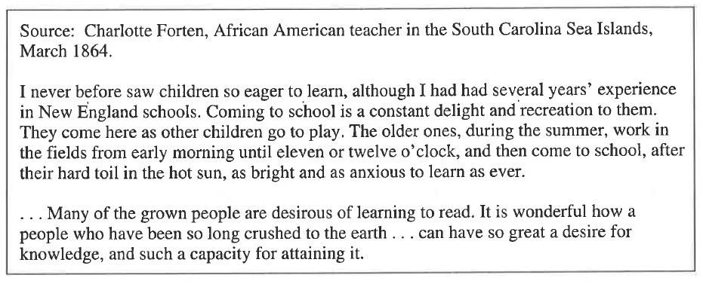

**Republican Platform**

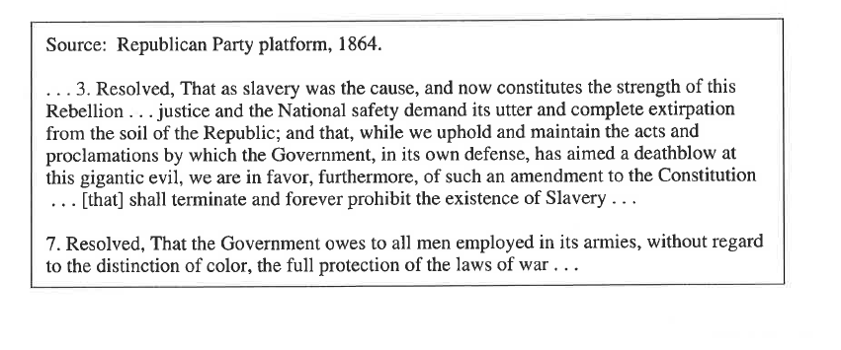

**40 acres and a mule**

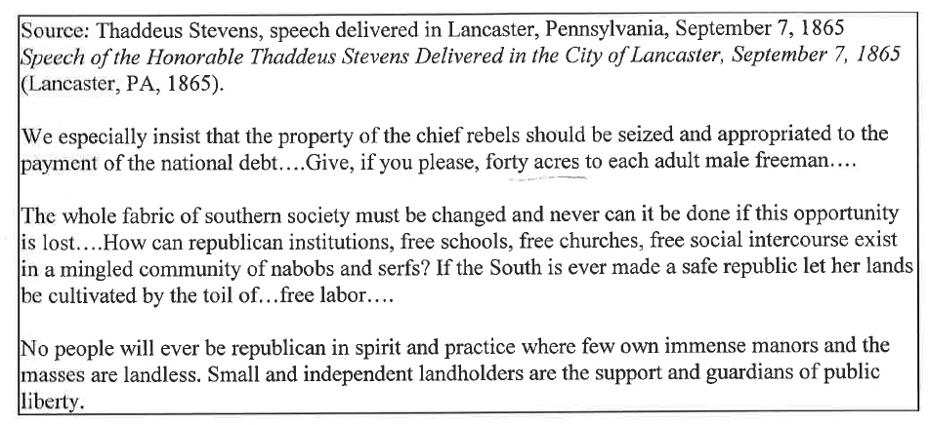

**Southern Attitudes**

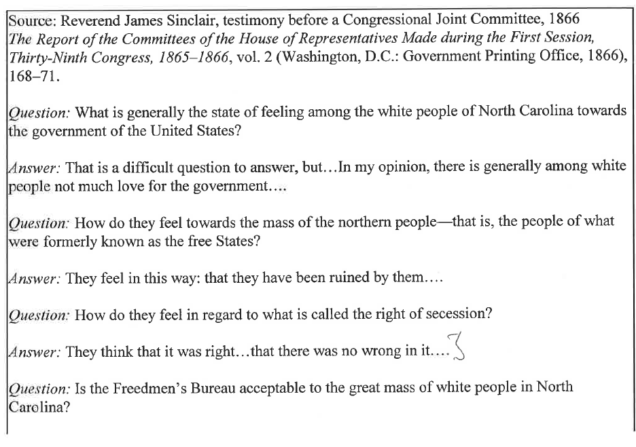

*Answer:* No, sir; I do not think it is; I think most whites wish the bureau to be taken away.…They think that they can manage the negro better for themselves: that they understand him better than northern men do.

**Worse than Slavery**



