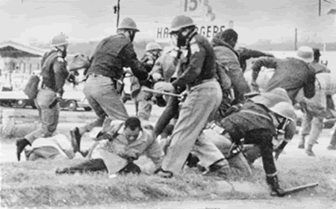
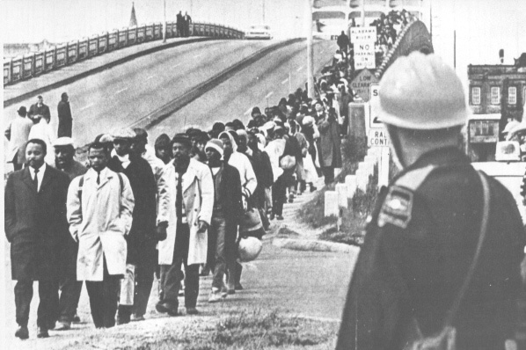
On 2 January 1965 King joined other local African American activists in a voting rights campaign in Selma where, in spite of repeated registration attempts by local blacks, only two percent were on the voting rolls. His organization, SCLC, had chosen to focus its efforts in Selma because they anticipated that the notorious brutality of local law enforcement under Sheriff Jim Clark would attract national attention and pressure President Lyndon B. Johnson and Congress to enact new national voting rights legislation.
The campaign in Selma and nearby Marion, Alabama, progressed with mass arrests but little violence for the first month. That changed in February, however, when police attacks against nonviolent demonstrators increased. On the night of 18 February, Alabama state troopers joined local police breaking up an evening march in Marion. In the ensuing melee, a state trooper shot Jimmie Lee Jackson, a 26-year-old church deacon from Marion, as he attempted to protect his mother from the trooper’s nightstick. Jackson died eight days later in a Selma hospital.
In response to Jackson’s death, activists in Selma and Marion set out on 7 March, to march for 5 days, 54 miles, from Selma to the state capitol in Montgomery. While King was in Atlanta, his SCLC colleague Hosea Williams, and SNCC leader John Lewis led the march. The marchers made their way through Selma across the Edmund Pettus Bridge, where they faced a blockade of state troopers and local lawmen commanded by Clark and Major John Cloud who ordered the marchers to disperse. When they did not, Cloud ordered his men to advance. Cheered on by white onlookers, the troopers attacked the crowd with clubs and tear gas. Mounted police chased retreating marchers and continued to beat them.
Television coverage of ‘‘Bloody Sunday,’’ as the event became known, triggered national outrage. Lewis, who was severely beaten on the head, said: ‘‘I don’t see how President Johnson can send troops to Vietnam—I don’t see how he can send troops to the Congo—I don’t see how he can send troops to Africa and can’t send troops to Selma,’’
That evening King began a blitz of telegrams and public statements, ‘‘calling on religious leaders from all over the nation to join us on Tuesday in our peaceful, nonviolent march for freedom’’ (King, 7 March 1965). While King and Selma activists made plans to retry the march again two days later, Federal District Court Judge Frank M. Johnson, Jr. notified the movement attorney Fred Gray that he intended to issue a restraining order prohibiting the march until at least 11 March, and President Johnson pressured King to call off the march until the federal court order could provide protection to the marchers.
Forced to consider whether to disobey the pending court order, after consulting late into the night and early morning with other civil rights leaders and John Doar, the deputy chief of the Justice Department’s Civil Rights Division, King proceeded to the Edmund Pettus Bridge on the afternoon of 9 March. He led more than 2,000 marchers, including hundreds of clergy who had answered King’s call on short notice, to the site of Sunday’s attack, then stopped and asked them to kneel and pray. After prayers they rose and turned the march back to Selma, avoiding another confrontation with state troopers and skirting the issue of whether to obey Judge Johnson’s court order. Many marchers were critical of King’s unexpected decision not to push on to Montgomery, but the restraint gained support from President Johnson, who issued a public statement: ‘‘Americans everywhere join in deploring the brutality with which a number of Negro citizens of Alabama were treated when they sought to dramatize their deep and sincere interest in attaining the precious right to vote.” Johnson promised to introduce a voting rights bill to Congress within a few days.
That evening, several local whites attacked James Reeb, a white Unitarian minister who had come from Massachusetts to join the protest. His death two days later contributed to the rising national concern over the situation in Alabama. Johnson personally telephoned his condolences to Reeb’s widow and met with Alabama Governor George Wallace, pressuring him to protect marchers and support universal suffrage.
On 15 March Johnson addressed the Congress, identifying himself with the demonstrators in Selma in a televised address: ‘‘Their cause must be our cause too. Because it is not just Negroes, but really it is all of us, who must overcome the crippling legacy of bigotry and injustice. And we shall overcome.” The following day Selma demonstrators submitted a detailed march plan to federal Judge Frank M. Johnson, Jr., who approved the demonstration and enjoined Governor Wallace and local law enforcement from harassing or threatening marchers. On 17 March President Johnson submitted voting rights legislation to Congress.
The federally sanctioned march left Selma on 21 March. Protected by hundreds of federalized Alabama National Guardsmen and Federal Bureau of Investigation agents, the demonstrators covered between 7 to 17 miles per day. Camping at night in supporters’ yards, they were entertained by celebrities such as Harry Belafonte and Lena Horne. Limited by Judge Johnson’s order to 300 marchers over a stretch of two-lane highway, the number of demonstrators swelled on the last day to 25,000, accompanied by Assistant Attorneys General John Doar and Ramsey Clark, and former Assistant Attorney General Burke Marshall, among others.
On 6 August, in the presence of King and other civil rights leaders, President Johnson signed the Voting Rights Act of 1965. Recalling ‘‘the outrage of Selma,’’ Johnson called the right to vote ‘‘the most powerful instrument ever devised by man for breaking down injustice and destroying the terrible walls which imprison men because they are different from other men.’’

