PRO/CON: Should we celebrate Christopher Columbus?
By Silvio Laccetti, McClatchy Tribune, and Los Angeles Times Editorial Board
10/05/2017
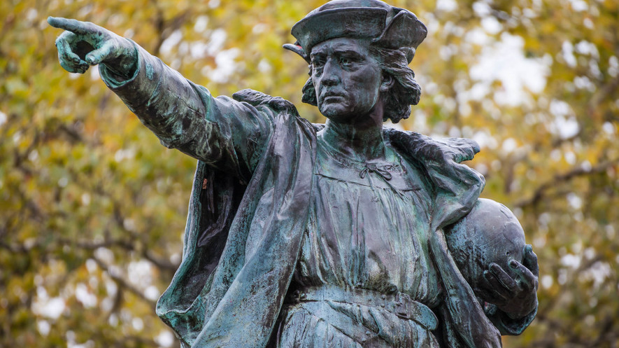
A statue of Christopher Columbus stands in Providence, Rhode Island. Photo by: Kenneth C. Zirkel/Wikimedia Commons

PRO: Columbus was a man of his time, history shows he is worth celebrating
With monuments honoring Christopher Columbus regularly being defaced and destroyed, it’s clear this year’s Columbus Day celebrations will elicit strong debate over the explorer’s legacy. But by looking at Columbus in the greater context of the history of civilizations, one can see that much of today’s anti-Columbian fury is either misguided or part of a blind political agenda seeking to demonize early European activity in the New World.

First off, let’s consider the matter of European disease transmission, principally smallpox, which is estimated by some to have killed 70 percent to 80 percent of the population native to the Americas. While those numbers are staggering, the deaths happened over many decades, and holding Columbus personally responsible is beyond preposterous. Further, calculating an actual number of deaths is impossible because estimates of pre-Columbus populations vary enormously. In the case of Hispaniola, for example, the range runs from 250,000 to 3 million.

It’s also worth remembering all the other epidemics in our history books. The Black Death, originating in Central Asia, killed 40 percent or more of the European people — some 50 million souls — in the brief period of 1346 to 1353. Such ravage of life is just one of the negative consequences that comes with the advancement and interactivity of civilizations world-wide. The pale horse and its rider pass through all societies.

And in the case of Columbus and the later Spanish settlement in the Americas, let’s remember, the exchange of disease worked both ways. Most historians believe that the Great Pox epidemic in Renaissance Europe was brought over from the New World. The pox, aka syphilis, initially killed some 5 million Europeans and continued taking a toll into the modern era.

Next, consider the civilizations and urban societies of the New World. They cannot be romanticized simply because they have left behind great monuments. The earliest ones, at Teotihuacan (outside Mexico City, Mexico) and the Mayan, were as brutal in their exploitation and treatment of subject peoples as any of the civilizations of the Ancient Near East.
Tourists love to visit the magnificent pyramids of Teotihuacan and the Mayan sites close to resorts. So beautiful! So inspiring! So conveniently located! Not so beautiful if you consider the human sacrifice that regularly occurred there. Woe betided the captives and slaves from conquered territories.
The later Aztec and Incan civilizations, encountered by the Conquistadores, were no more humane. War, captivity, slavery and human sacrifice were endemic — and pre-dated 1492.

How could Francisco Pizarro conquer the great Inca Empire with fewer than 200 men? How did Hernando Cortes overwhelm the powerful Aztecs? Answer: They found willing allies in subjugated, enslaved or rebellious native populations. Make no mistake about it. Civilization itself can be brutal.

European civilization has evolved past its early stages, but 20th century wars, atrocities, genocide and terrorism show humanity is still prone to the same savage impulses as Assyrians and Aztecs. Truthfully, warfare is one of the key institutions of civilization, as evidenced by today’s local wars and rumors of nuclear strikes.

Despite our druthers, we are products of our time. We fit into a greater context. So did Columbus, hence the negative in his legacy. But he also rose out of and above his time. He was a great explorer, an intrepid adventurer, a man of fervent faith and a defiant leader who blazed a path to the modern world. His admirable traits allowed him to rise above his human imperfections.

He holds a special place in the consciousness of Italian-Americans and Hispanic-Americans, who strongly identify with his accomplishments. These groups celebrate Columbus Day with parades and have commemorated him with statues in North and South America. The world’s largest Columbus monument is in Puerto Rico.

Christopher Columbus also enjoys iconic status in the wider American mind. Columbia, a female figure, is the personification of America (like Uncle Sam). Columbus was much admired by our founders. The District of Columbia carries his name. The Christopher Columbus Transcontinental Highway (Interstate 10) symbolically links the U.S. from sea to sea — and to the Admiral of the Ocean Seas. Parks, playgrounds, streets, squares, schools and sites of many other kinds pay homage to him.
No question, we must examine the accomplishments of Columbus. Doing so in the proper context shows there’s no justification in destroying, defacing or removing his monuments — or in minimizing his legacy.

Silvio Laccetti is a retired professor of social sciences at Stevens Institute of Technology in Hoboken, New Jersey.

PRO/CON: Should we celebrate Christopher Columbus?
By Silvio Laccetti, McClatchy Tribune, and Los Angeles Times Editorial Board
10/05/2017
A statue of Christopher Columbus stands in Providence, Rhode Island. Photo by: Kenneth C. Zirkel/Wikimedia Commons

CON: We must recognize that progress for some led to injustice for others
The Los Angeles City Council has replaced Columbus Day with an official holiday called Indigenous Peoples Day, to recognize the contributions, as well as the suffering, of the nation’s original inhabitants.

Of course, giving city workers a day off does not begin to make amends for centuries of discrimination, enslavement and government-sanctioned genocide of Native Americans. Nor does wiping Columbus Day off the calendar reverse the destruction of indigenous peoples’ sacred spaces or the attacks on their cultural heritage.

Without question, Los Angeles, along with California and the nation as a whole, must do a far better job recognizing the violent history of oppression that decimated the country’s indigenous people. California’s political leaders in the 1850s made no secret of their desire to exterminate the area’s native inhabitants. State legislators funded anti-Indian militias. Native people were massacred. Villages were destroyed and tribes forcibly relocated. Yet few Californians know the details of this terrible history.

Would a holiday help Californians learn about this shameful period and encourage the process of reconciliation? Possibly. But only if the symbolic holiday is paired with meaningful policies and honest statements. California’s leaders could consider, for instance, an official public apology for the state’s history of mistreating native peoples. Or they could debate whether to compensate tribes that lost sacred sites or return land that holds special value. The city could, if it chose, provide greater protection for sacred sites threatened by building projects or it could offer its official support for local tribes, many of which are still seeking federal recognition. The true stories of native peoples, beyond the simplistic portrayal of the first Thanksgiving meal, must become part of our national narrative. Schools should be required to teach the history, warts and all. Los Angeles has the nation’s second-largest population of Native Americans.

But the effort to raise public consciousness about the history of native peoples has become a zero-sum game. Proponents say it’s not enough to designate an Indigenous Peoples Day. The government also has to remove Columbus Day from the official calendar because, in these observers’ view, it honors a cruel slave trader whose arrival in the “New World” set into motion the mass killing of native peoples. Columbus represents the violent colonization of the Americas, they say, so in this war of symbolism Columbus Day must die so Indigenous Peoples Day can live.

But why must this be a binary choice? The debate over Columbus and his legacy reflects ongoing confusion in the United States about how the country’s history of racism and oppression fits into a proud national identity. The U.S. is a nation that has taken in millions of needy immigrants — but also grew through a colonization process that devastated native people. It’s a country that was founded by individuals fleeing oppression — but who then prospered on the labor of slaves. Even Columbus Day itself sends a bit of a mixed message: It wasn’t created to celebrate colonial domination at all but was designated as a federal holiday in the 1934 after a campaign by Italian-Americans and Catholics, who were then targets of ethnic and religious discrimination, to help establish their place in U.S. history.
Erasing history is not the answer. The better approach is to confront it straight on, honestly and comprehensively.

Whether the holiday is called Columbus Day or Indigenous Peoples Day or Explorers Day or History Day, is it not possible to honor the spirit and ambition of exploration while also acknowledging the terrible damage inflicted by the colonial powers? Isn’t there a way to celebrate the rise of a democratic nation built on a promise of liberty and equality, while also recognizing that progress for some led to displacement, injustice and death for others? There should be.
The Los Angeles Times Editorial Board represents the opinions of the publisher and staff of the newspaper.

