The Age of Reagan
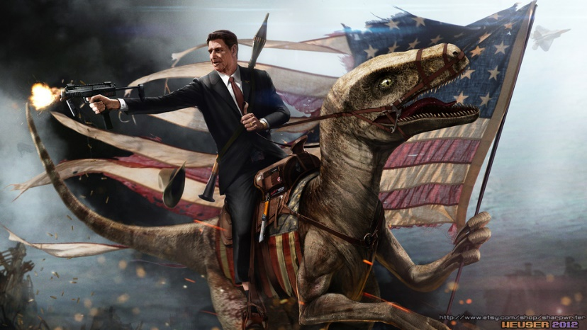
The Reagan Revolution of the 1980s sought to change Americans’ attitudes toward their country, their government, and the world, as the United States emerged from the 1970s. Ronald Reagan entered the White House in January 1981 promising to restore Americans’ faith in their nation and themselves, to shrink “Big Government,” and to defend America more aggressively, especially against the Soviet Union. During his two terms in office, President Reagan continued his decades-long battle against Great Society liberalism, the activities and ideas of the 1960s’ student rebels and 1970s’ defeatists, and the spread of Communism. Reagan’s American restoration delivered patriotism, prosperity, and peace. American pride revived as the economy soared and the Soviet domination of Eastern Europe collapsed. “All in all,” Reagan said in his 1989 farewell address, “not bad, not bad at all.”
Critics consider the Reagan Revolution reactionary, an assault against the great liberal gains that, over the previous fifty years, had democratized and humanized America. They claim Reagan widened the gap between rich and poor, encouraged greed, and threatened the accomplishments of the civil rights, feminist, and environmental movements. The intensity of the ongoing debate more than three decades after his inauguration demonstrates the Reagan Revolution’s continuing resonance.
As president, Reagan challenged the problems of the 1970s. During that decade, America had seemed adrift, demoralized by the loss of the Vietnam War, humiliated by the Watergate scandal and Richard Nixon’s resignation, endangered by Soviet expansion, disrespected by Third World dictators, starved of oil, battered by inflation, haunted by unemployment, menaced by crime, imprisoned by doubt. Reagan and his fellow conservatives blamed “Big Government,” meaning the welfare state, for the domestic troubles, accusing government bureaucrats of mismanaging the economy and crushing individual initiative. Conservatives championed “supply side” economics, trusting that cutting taxes and regulation would allow Americans to produce—supply—more. Reaganaut conservatives also blamed government growth on Communism’s influence, which to them also explained America’s failure to confront the Soviet Union. While by the 1970s, most conservatives endorsed the Civil Rights Movement, they fought against abortion, busing, and the negative impact they believed the sixties’ movements, including feminism, had had on American families and society.
Born in 1911 in Illinois, Ronald Reagan was a New Deal Democrat in the 1930s and a famous “B” movie actor in the 1940s, who by the 1950s believed the Democrats were overtaxing and over-regulating. He always insisted: “Maybe my party changed. I didn’t.” Reagan’s acting background caused many to underestimate him in politics; he wondered how anyone could be in politics without first having been in show business.
In 1964, Reagan gave a nationally broadcast speech for Barry Goldwater’s presidential campaign. Goldwater lost, but “The Speech,” as it was remembered, helped launch Reagan’s political career. Goldwater’s conservatism was cranky; Reagan’s came with a happy face and light quips, as he claimed, for example, that “The nine most terrifying words in the English language are, ‘I’m from the government and I’m here to help.’”
Prominent California businessmen urged him to run for governor. He did, and he won. During his two terms as California’s governor, from 1967 to 1975, Reagan was beloved by the right and hated by the left. He confronted radicals in Berkeley and mocked hippies as people who “dress like Tarzan, have hair like Jane, and smell like Cheetah.” Yet despite his bravado, he compromised on key conservative principles, including signing a 1967 bill allowing abortions if necessary for the mother’s health.
After losing the Republican nomination to President Gerald Ford in 1976, Reagan unseated the Democratic President Jimmy Carter in 1980. This became an “ABC” election, with many choosing “Anybody but Carter,” yet Reagan claimed he had received a mandate for change. His Electoral College vote of 489 to 49 magnified his bare majority of 50.7 percent of popular votes cast. Carter received 41 percent and the Republican renegade John Anderson attracted 6.6 percent. Republicans also captured the Senate for the first time in thirty years, although the House of Representatives remained Democratic.
As president, Reagan promised to cut the budget, reduce taxes, trim the bureaucracy, revive America, and subdue the Soviets. At his inauguration, he proclaimed: “In this present crisis, government is not the solution to our problem, government is the problem.” During his first seven and a half months in office, Reagan unveiled “Reaganomics,” securing the largest budget cut ever—some $35 billion in domestic spending from Jimmy Carter’s request—and reducing the personal income tax rate by almost one quarter. In March 1981, a crazed gunman shot Reagan. The President’s wisecracks throughout the ordeal increased his popularity, overcoming what had been growing opposition to the cutbacks. In the operating room, Reagan quipped, “I hope you are all Republicans.” His surgeon, a Democrat, replied: “Today, Mr. President, we are all Republicans.”
By the summer of 1981, with Americans experiencing the highest unemployment rate since the Great Depression, Democrats attacked the “Reagan Recession.” Getting traction on the “Fairness Issue,” critics led by the Democratic Speaker of the House, Tip O’Neill, attacked the President as Mr. Magoo, a bumbling anti-Communist cowboy, a reverse Robin Hood, and a warmonger. They said he cut taxes for the rich and burdened the poor while risking nuclear war by calling the Soviet Union the “Evil Empire.” They mocked his gaffes, from blaming air pollution on trees to falling asleep at Cabinet meetings—which he defused by insisting: “I have left orders to be awakened at any time in case of national emergency, even if I’m in a Cabinet meeting.” In 1982, twenty-seven new Democratic House seats restored the losses from 1980, although the Senate remained Republican. Pundits eulogized Reagan’s failed presidency.
The economy revived before Reagan had to face the electorate for re-election. A ninety-six-month-long economic boom began, and ultimately yielded 20 million new jobs. Inflation dropped from double-digit levels under Carter to 8.9 percent in 1981, then to 4 percent in 1984. With American pride returning too, Reagan blessed the prosperity as “Morning in America.”
Reagan’s second term was rockier than the first. The oldest president ever, he turned seventy-four shortly after his second inauguration. In 1985, his visit to a military cemetery in Bitburg, Germany, that also had the graves of Nazi SS killers shook his standing as America’s popular patriot. In 1986, the Iran-Contra scandal, involving illegal arms shipments to Iran and Central America, along with the Democratic recapture of the Senate, further diminished his popularity and power. In 1987, Reagan could not even get Robert Bork, his first choice to fill a Supreme Court vacancy, confirmed by the Senate.
Yet the Reagan Revolution was redeemed as the economic boom continued, pride in America surged, and the Cold War ended. Initially, Reagan, British Prime Minister Margaret Thatcher, and Pope John Paul II were ridiculed for believing Soviet Communism was beatable. By 1985, when the young reformer Mikhail Gorbachev rose to power in the Soviet Union, Soviet weakness became more obvious.
Reagan had a surprising anti-nuclear, pacifist streak, despite his saber-rattling and massive defensive buildup. In summit meetings with Gorbachev, America’s anti-Communist president proved friendly and flexible. In June 1987, when visiting West Berlin and standing at the Berlin Wall, which the Soviets had erected to prevent East Germans from fleeing to the free West, Reagan demanded: “Mr. Gorbachev tear down this wall.” This dramatic moment helped Reagan claim that his approach beat Communism as the Berlin Wall fell, Soviet domination of Eastern Europe came to an end, and, by 1991, the Soviet Union disappeared. Although America’s victory in the Cold War was a bipartisan triumph, stretching back to Harry Truman’s “containment strategy,” the Reagan Revolution deserves credit too.
Ronald Reagan called his presidency “the great rediscovery”—“a rediscovery of our values and our common sense.” He retired, still encouraging Americans to make America “a shining city upon the hill,” frustrated that his “revolution” only slowed the rate of government growth. Reagan won a virtual third term as his vice president, George H.W. Bush, succeeded him.
Promising a “kinder, gentler” nation, President Bush continued Reagan’s revolution with a softer touch, alienating fewer liberals. When the Democrat Bill Clinton ran for president in 1992, he targeted Reaganite “greed,” accusing Reagan of neglecting middle-class Americans as the gap between rich and poor grew. Many Americans considered the 1991–1992 downturn payback for Reagan’s high budget deficits.
Still, Reagan’s anti-government message resonated, even in a Democratic administration. Clinton won re-election in 1996, only after pronouncing “The era of big government is over” and reforming welfare. As Ronald Reagan faded into the haze of Alzheimer’s, and as the Reagan-Bush-Clinton economic boom, which was the result of the Baby Boom, continued, Americans remembered Reagan fondly as the prince of peace and prosperity, a genial, witty optimist who restored American pride and patriotism.
After 2000, many Democrats who hated George W. Bush forgot how much they had detested Reagan, to prove they did not hate all Republicans. When Barack Obama ran for president in 2008, he called Reagan a transformational leader. Obama yearned to replicate the Reagan Revolution’s impact, although he repudiated its content.
Three decades after the Reagan Revolution began we still live in a Reaganized America. With debates about “Big Government” and tax cuts continuing, the Reagan Revolution remains unfinished. But it is one of twentieth-century America’s most significant political movements.

Gil Troy is a professor of history at McGill University in Montreal and author of The Reagan Revolution: A Very Short Introduction (2009), Leading from the Center: Why Moderates Make the Best Presidents (2008), and Morning in America: How Ronald Reagan Invented the 1980s (2005).

