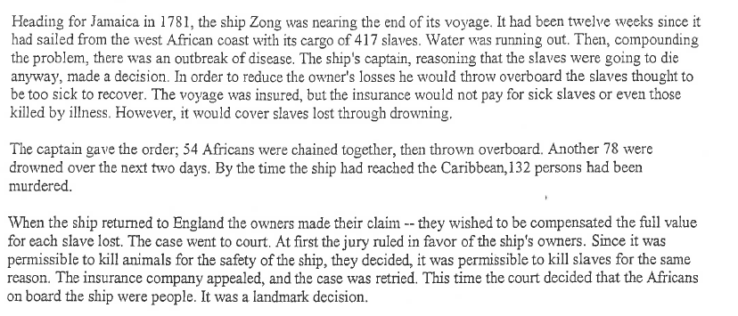
The Murder of Slaves
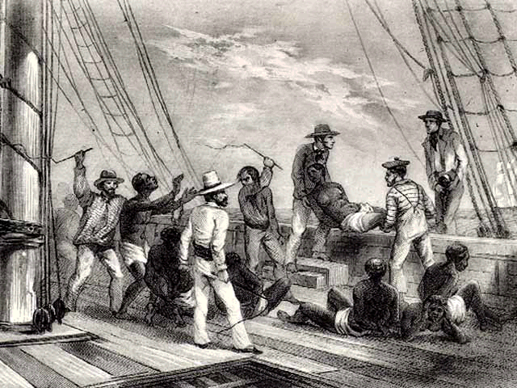

Questions:
- What is being depicted in the image?
- Why were the slaves thrown overboard?
- Why did the slave ship captain not get in trouble initially for throwing slaves overboard?
- When the case was retried, what did the courts decide?

Slave Restraints
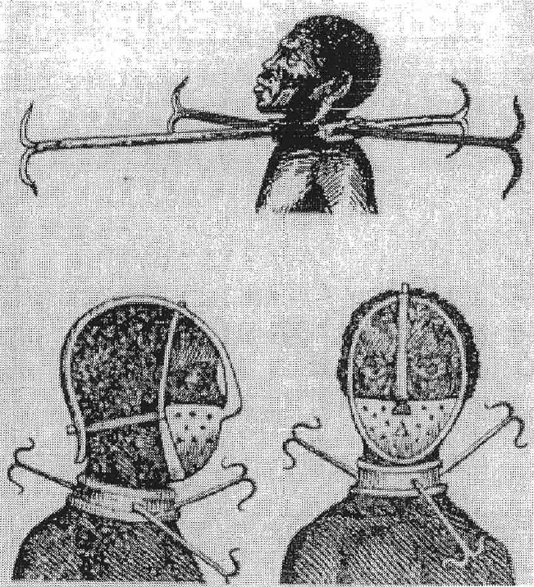

Questions:
- What is being depicted in the image?
- Why do you think Africans need these collars?
- How do you think Europeans viewed Africans?
- How would this view affect their treatment of Africans?

The Middle Passage
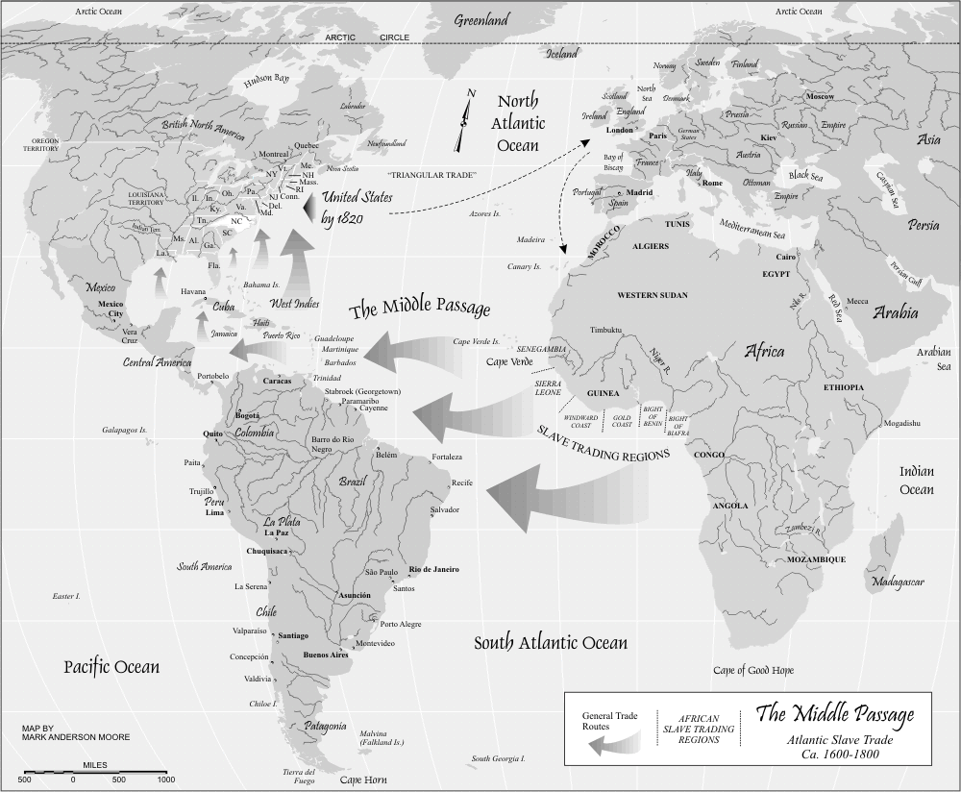
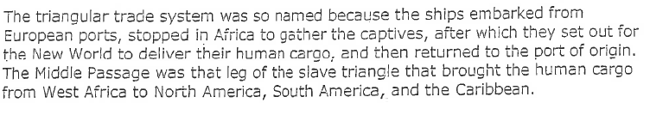
Questions:
- What is being depicted in the map?
- What were the advantages of the Triangle Trade system for Europeans?
- What were the disadvantages of the Triangle Trade?

The Slave Ship
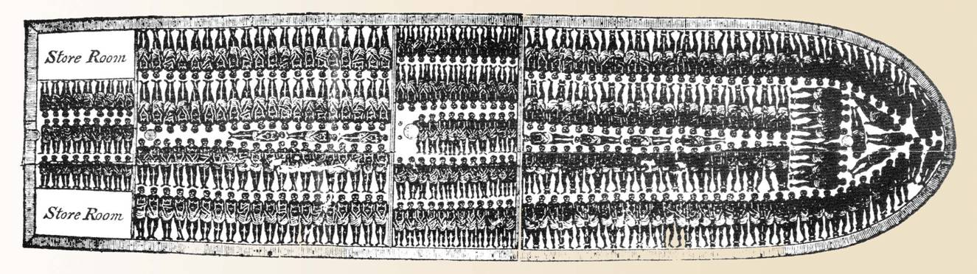
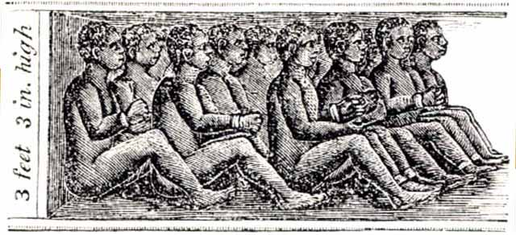

Questions:
- What is being depicted in the images?
- How do these pictures reflect the attitudes of Europeans towards Africans?
- What can you infer about the conditions onboard ships during the Middle Passage?

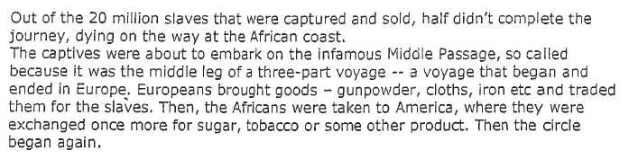
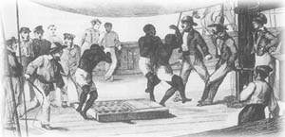
The Slave Trade

Questions:
- Why is the voyage of slaves from Africa to the Americas called the Middle Passage?
- What did Europeans bring and sell in Africa?
- What did Europeans bring and sell from the Americas to Europe?
- Why do you think so many slaves died during the Middle Passage?

