The Zimmermann Note
"No other single cryptanalysis has had such enormous consequences."
–David Kahn, author of Codebreakers
Between 1914 and the spring of 1917, the European nations engaged in a conflict that became known as World War I. While armies battled in Europe, the United States remained neutral. In 1916 Woodrow Wilson was elected President for a second term, largely because of the slogan "He kept us out of war." Events in early 1917 would change that hope.
In January of 1917, British cryptographers deciphered a telegram from German Foreign Minister Arthur Zimmermann to the German Minister to Mexico, von Eckhardt, offering United States territory in return for joining the German cause. To protect their intelligence from detection and to capitalize on growing anti-German sentiment in the United States, the British waited to present the telegram to President Wilson. Meanwhile, frustration over the effective British naval blockade caused Germany to break its pledge to limit submarine warfare. In response, the United States severed diplomatic relations with Germany in February.
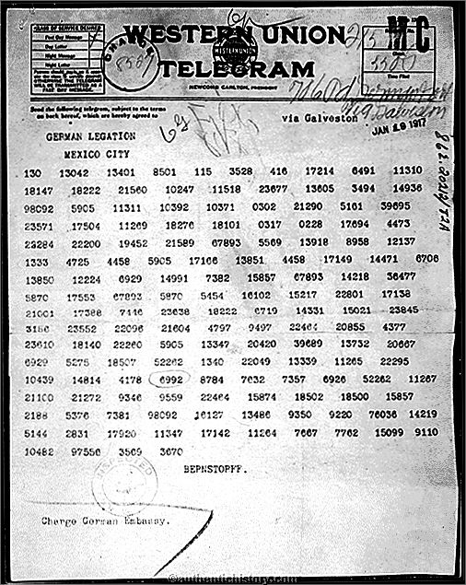
On February 24 Britain released the Zimmermann telegram to Wilson, and news of the telegram was published widely in the American press on March 1.

Transcript of Zimmermann Telegram (1917)
(Decoded message text of the Zimmermann Telegram) Example practice: XFD GAV

"We intend to begin on the first of February unrestricted VVXAAA VADG
AVDADF AF XFD GAVFG DGAVAF. We shall endeavor in spite of this to keep the United States of America neutral. In the event of this not succeeding, we make VAAF XGDAD XVD a proposal or alliance on the following basis: make XFDG AV together, make peace together, generous financial support and an understanding on our part that Mexico is to reconquer the
A XVDVV VXVXA FAVAV DAVXV DAVXV in VXAFXGDG VV, New Mexico, and DG AVDAXXVDDF DG. The settlement in detail is left to you. You will inform the President of the above most secretly as soon as the outbreak of war with the United States of America is certain and add the suggestion that he should, on his own initiative, invite GGDG VF DGDF to immediate adherence and at the same time mediate between GGDG VF DGDF and ourselves. Please call the President's attention to the fact that the ruthless employment of our submarines now offers the prospect of compelling England in a few months to make peace."
Signed, XXDAV AVAAF AVVAD GDFDF.

Name:
Zimmermann Note Analysis
1) What are the German intentions with respect to the United States?

2) How does Germany intend to assist Mexico should they join the effort?

3) Why would Germany think to involve Japan in this process?

4) Why would Germany think that Mexico would be willing to do declare war on the United
States?

5) What does Germany anticipate in terms of the future course and location of the war?

6) Based on the information presented in the Zimmermann telegram, is the United States justified in entering the war?

